Introduction to Economics

What is Economics?

What is Economics? The word originates from the link of two Greek words: oikos (“house”) and nomos (“law”), so it literally means “regulation of the house”. A great 19th-century economist, Alfred Marshall, defined economics as “a study of mankind in the ordinary business of life”. The basic definition is (from Investopedia):

Economics is a social science concerned with the production, distribution, and consumption of goods and services. It studies how individuals, businesses, governments, and nations make choices about how to allocate resources. Economics focuses on the actions of human beings, based on assumptions that humans act with rational behavior, seeking the most optimal level of benefit or utility. The building blocks of economics are the studies of labor and trade. Since there are many possible applications of human labor and many different ways to acquire resources, it is the task of economics to determine which methods yield the best results.

Economics can vacillate according to the circumstances, but in general we have an increasing trend: economies tend to grow, even if sometimes we might have bad periods.

Economics can generally be broken down into microeconomics, which focuses on individual people and businesses (consumers’ choices, production choices, market equilibrium, etc.), and macroeconomics, which concentrates on the behaviour of the economy as a whole (unemployment, inflation, growth, etc.).

Hesiod and Plato first discussed about economic aspects, but the first scholars to discuss about it were the physiocrats in the XVIII century. After that came Adam Smith’s “The Wealth of Nations” and Jeremy Bentham, as well as John Stuart Mill, Marshall, Karl Marx and finally, Keynes and new classical economics. Before modern times, economics was an integral part of philosophical discourse.

Microeconomics

What is Microeconomics? Microeconomics is the social science studying how individuals (called economic agents) make decisions given scarcity. It’s a social science because its assumptions are not neutral and are not necessarily true, as there are theories based on a different set of assumptions. But what is this scarcity we mentioned above?

With scarcity, we’re referring to scarcity of income, of time, and of resources. Scarcity is a situations in which the amount of something available is insufficient to satisfy the desire for it. All these types of scarcity stem from two basic limitations:

1. Scarce time
2. Scarce spending power

PEOPLE MUST MAKE CHOICES BECAUSE RESOURCES ARE SCARCE

These two limitations force each of us to make choices, and economists study how we make these choices as individuals and consequences of those choices. Economists also study more subtle and indirect effects of individual choice on our society.

But how do individuals make choices? Economic agents (individuals) are rational utility-maximisers and proceed according to the Rational choice theory: individuals have preferences among the alternative choices. Each individual facing a choice among alternatives uses all the available information to compute the costs and benefits associated to all the alternatives and choose the one that maximises the net benefit (= benefits-costs). More recently, the study of this can be referred to as behavioural economics.

From a Macroeconomic perspective, scarcity takes a variety of forms:

1. Scarcity of labour (time humans spend producing goods and services)
2. Scarcity of capital (something produced that is long-lasting, and used to make other things that we value, including physical and human capital)
3. Scarcity of land/natural resources (the physical space on which production occurs and the natural resources that come with it)

THE REAL COST OF SOMETHING IS WHAT YOU MUST GIVE UP TO OBTAIN IT

While monetary measures of cost of an item suffice for many goods, it can be very deceptive for others. Economists emphasise that the true cost of a choice that we make is the opportunity cost; i.e., what you must give up in order to obtain the item in question. Therefore, we should consider Opportunity Cost, which includes both the monetary and non-monetary cost of a choice. There are things such as Implicit or Indirect Costs that we don’t consider when dealing with superficial monetary sacrifices, but that we shouldn’t forget about when paying, for example, a college education.

“HOW MUCH” IS A DECISION AT THE MARGIN

How is a decision made at a margin, though? Some important decisions involve an “either-or” choice – for example, you decide either to go to college or to begin working; you decide either to take economics or to take something else. Other important decisions involve “how much” choices – for example if you are taking both economics and philosophy this semester, you must decide how much time to spend studying for each. When it comes to understanding “how much” decisions, economics has an important insight to offer: “how much” is a decision made at the margin. Marginal Analysis is a crucial part of Economics.

PEOPLE USUALLY EXPLOIT OPPORTUNITIES TO MAKE THEMSELVES BETTER OFF

In order to understand people’s behaviour in any Economy, we need to understand the incentives they face (an incentive is anything that offers rewards to people who change their behaviour). Let’s look at this example:

* The electric power company offers a $100 rebate for individuals   
  purchasing an efficient refrigerator
* Individuals on welfare programs would lose much, if not all, of their benefits if they get a job
* Conditional Cash Transfers Programs in Latin America (ex. Progresa/Oportunidades) provide cash transfers to poor households that meet certain requirements (enrolment of children at school, vaccinations, visits in health centres)

The principle that people will exploit opportunities to make themselves better off is the basis of all predictions by economists about individual behaviour. Economists tend to be quite sceptical of any attempt to change people’s behaviour that doesn’t change their incentives.

THERE ARE GAINS FROM TRADE

A market economy relies upon this basic principle; i.e., that people can get more of what they want through trade than by being self-sufficient. These gains stem from the fact that total output can be increased with specialisation. This idea applies to:

* The Household
* A Firm
* Communities
* Nations

MARKETS MOVE TOWARDS EQUILIBRIUM

As the book defines it, an economic situation is in equilibrium when no individual would be better off doing something different. Changing conditions create opportunities (incentives) that a market economy encourages individuals to take advantage of, moving us to a new equilibrium.

RESOURCES SHOULD BE USED AS EFFICIENTLY AS POSSIBLE TO ACHIEVE SOCIETY’S GOALS

An economy is efficient (or Pareto Optimal) if there is no way to make anyone better off without making others worse off; recessions are an example of a situation of inefficiency. It is important to note, however, that efficiency is not a very strong criteria, as it says nothing about the equity of the situation.

MARKETS USUALLY LEAD TO EFFICIENCY

A market economy creates incentives for each individual, acting in their own self interest, to increase efficiency; this is what Adam Smith called the Invisible Hand. If there is unmet demand for a commodity at current price, individuals will bid up the price for the good, creating an incentive for producers to increase production until that demand is met.

WHEN MARKETS DON’T ACHIEVE EFFICIENCY, GOVERNMENTS CAN IMPROVE SOCIETY’S WELFARE

Although markets tend to lead to efficiency, there are many types of market failures, including:

* Externalities
* Market power
* Public goods
* Common property resources

When markets don’t achieve efficiency, governments can (but don’t necessarily) improve society’s welfare. Understanding the source of the market failure can be key to resolving the inefficiency, and in many cases, the problem stems from poorly-defined property rights or an incomplete market for the good.

ONE PERSON’S SPENDING IS ANOTHER PERSON’S INCOME

An example is that many conditional and unconditional cash transfers programs in Latin America and Africa have proved to improve income and consumption of non-beneficiary households. Cash transfers programs generate positive spillover (in consumption and production) on the local economy.

OVERALL SPENDING SOMETIMES GETS OUT OF LINE WITH THE ECONOMY’S PRODUCTIVE CAPACITY

Recessions are an example of this, and many argue that it was WWII that largely brought the US out of the Great Depression. Spending, for example, can also lead to inflation.

GOVERNMENT POLICY CAN CHANGE SPENDING

Cash Transfers Programs are an example of policy intervention in developing countries aimed at increasing consumption in more nutritious food, spending in education, spending in agricultural assets. Examples are:

* Child Grant Program in Lesotho
* Social Cash Transfers Program in Malawi
* Harmonised Social Cash Transfers in Zimbabwe

The Economic Stimulus Package is an example of such an effort: the Congress approved the American Recovery and Reinvestment Act (ARRA) in February 2009. The economic stimulus package ended the Great Recession by spurring consumer spending. Most importantly, it instilled the confidence needed to boost economic growth. It also aimed to restore trust in the financial services industry.

ARRA had three spending categories:

* It cut taxes by $224 billion
* It spent $224 billion in extended unemployment benefits, education, and health care
* It created jobs by allocating $275 billion in federal contracts, grants, and loans

DOING RESEARCH IN ECONOMICS

How do we do research in Economics? We tend to navigate according to two models:

1. Theoretical Models

* Provide frameworks for thinking about the factors that might influence behaviour
* Generate hypotheses whose validity can be assessed through empirical work
* Virtue of simplicity: reduces a problem to its essentials

1. Empirical Analysis

* Used to test hypotheses
* Causation vs Correlation

The Behaviour of a Market

A competitive market has many buyers and sellers of the same good or service, none of whom can influence the price. The supply and demand model is a model of how.a competitive market behaves. The two main forces driving the quantity and price that would be sold in a specific period are the supply and demand. Sellers don’t have to invest money to enter the market and won’t lose money by leaving it.

The supply and demand model is made up of five key elements:

1. The demand curve

This represents the behaviour of buyers and shows the quantity demanded at various prices. The quantity demanded is the quantity that buyers are willing/able to purchase at a particular price. As price falls, the quantity demanded rises, and vice-versa.

Saying there’s a change in demand means that people demand a larger/smaller amount of a commodity at the same price, while a change in quantity demanded means that the price has changed and so did consumers’ behaviour towards that product.

Why do demand curves shift to the right or to the left? Here is why:

* CHANGES IN THE PRICES OF RELATED GOODS OR SERVICES

Two goods are substituted if a decrease in the price of one leads to a decrease in the demand for the other (or vice-versa). Substitutes are usually goods that in some way serve a similar function (coffee and tea, muffins and donuts, etc.).

Some goods, however, are complements; they cannot be substituted, but consumed together (e.g.: SUVs and gasoline). Some goods can also be independent.

* CHANGES IN INCOME

The effect of changes in income on demand depends on the nature of the good in question:

* A normal good (demand increases when income increases, and vice-versa)
* An inferior good (demand decreases when income increases, and vice-versa)
* CHANGES IN TASTES

Tastes and preferences are subjective and vary among customers. Seasonal changes or fads have a predictable effect on demand.

* CHANGES IN EXPECTATIONS

If consumers have a choice about the timing of a purchase, they buy according to expectations. Buyers adjust current spending in anticipation of the direction of future prices in order to obtain the lowest price possible.

* CHANGES IN THE NUMBER OF CONSUMERS

As the population of an economy changes, the number of buyers of a particular good also changes (thereby changing its demand).

1. The supply curve

Supply represents the behaviour of sellers. A supply curve shows the quantity supplied at various prices. The quantity supplied is the quantity that producers are willing and able to sell at a particular price.

1. The set of factors that cause the demand curve to shift and the set of factors that cause the supply curve to shift

An increase in supply/demand means a rightward shift of the supply/demand curve, and a leftward shift of the supply/demand curve means a decrease in supply/demand. Important supply/demand shifters include changes in:

* Input prices

An input is a good or service that is used to produce another good or service. Inputs, like outputs, have prices. A decrease in the price of an input increases profits and encourages more supply (and vice versa).

* The prices of related goods and services

A single producer often produces a mix of goods rather than a single product. E.g.: oil refinery produces gasoline from crude oil but it also produces heating oil and other products from the same raw material. When a producer sells several products, the quantity of any one good it is willing to supply at any given price depends on the prices of its other co-produced goods.

In contrast, due to the nature of the production process, other goods can be complements in production. E.g.: higher oil prices lead to more natural gas supplied at any given price because oil and natural gas can be tapped simultaneously.

* Technology

New, better technology makes sellers willing to offer more at a given price or sell their quantity at a lower price. A technological innovations lowers costs and increases supply.

* Expectations

The expectation of a higher price for a good in the future decreases current supply of the good — if they can store the good (and vice versa).

Sellers will adjust their current offerings in anticipation of the direction of future prices in order to obtain the highest possible price. An increase in the anticipated future price of a good or service reduces supply today, a leftward shift of the supply curve.

A change in producers’ expectations about profitability will affect supply curves.

* The number of producers

As producers enter and exit the market, the overall supply changes:

* Entry implies more sellers in the market, increasing supply
* Exit implies fewer sellers in the market, decreasing supply

1. The market equilibrium, which includes the equilibrium price and the equilibrium quantity
2. The way the equilibrium changes when the supply curve or demand curve shifts

Consumer and Producer Surplus

Markets are (usually) efficient: we can measure their benefit to society by measuring:

* CONSUMER SURPLUS

The difference between market price and what consumers would be willing to pay.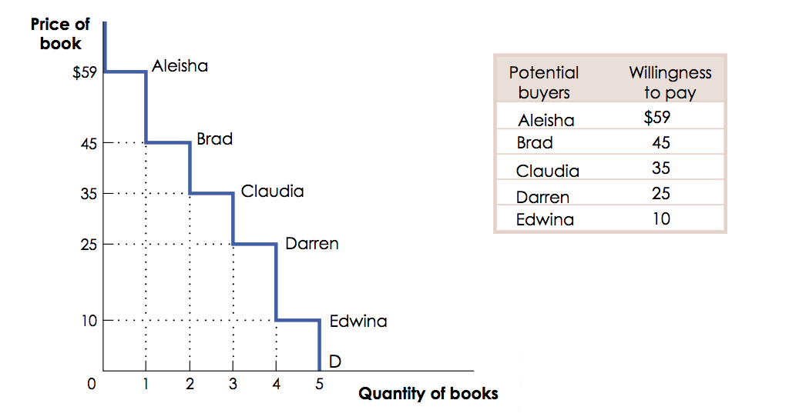

A consumer’s willingness to pay for a good is the maximum price at which they would buy that good. A total consumer surplus is the sum of the individual consumer surpluses of the consumers considered.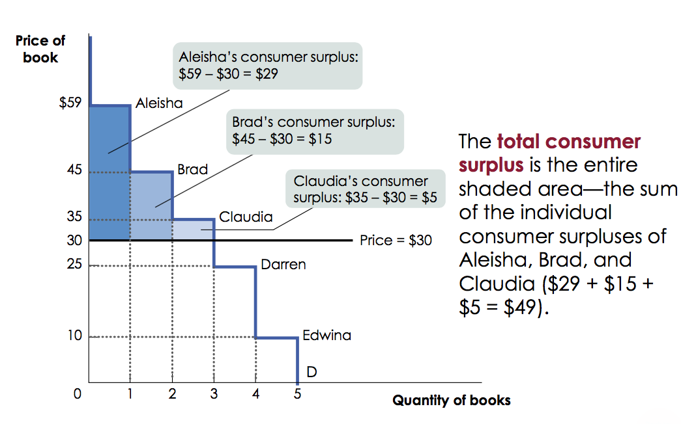

A consumer surplus is the area beneath the demand curve and above the price:

In general, the rule of thumb is that consumer surplus rises with a fall in price. The way the gains in consumer surplus are split is the following:

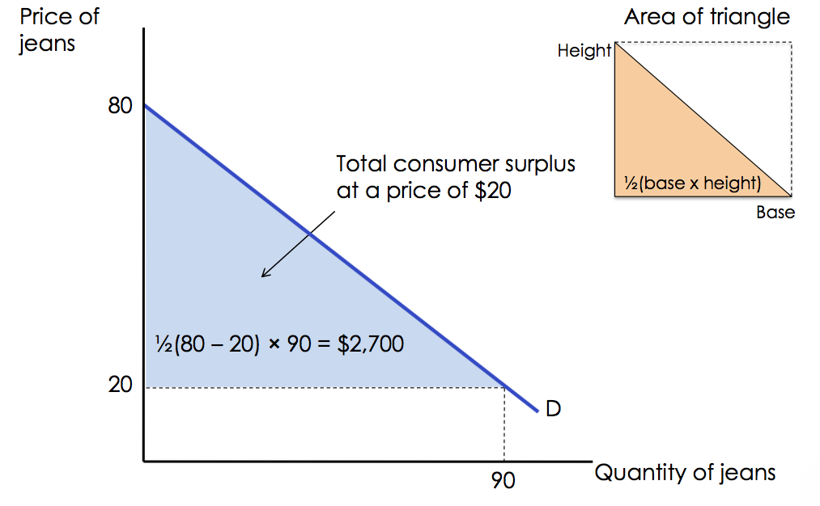

* PRODUCER SURPLUS

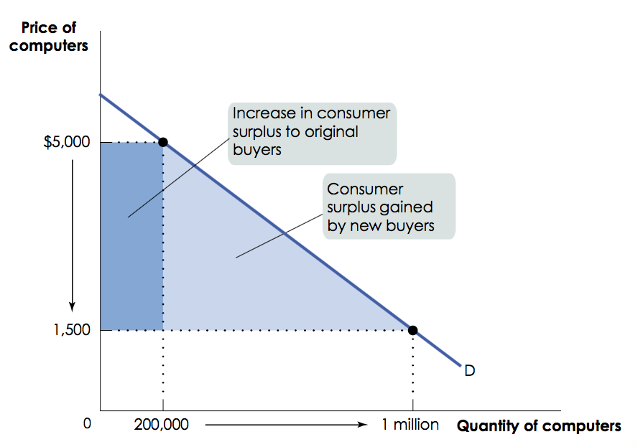 Producer surplus is the difference between market price and the price at which firms are willing to supply the product. Producer surplus is a measure of producer welfare. It is shown graphically as the area above the supply curve and below the equilibrium price.

Let’s consider this graph:

Producer surplus can be represented as: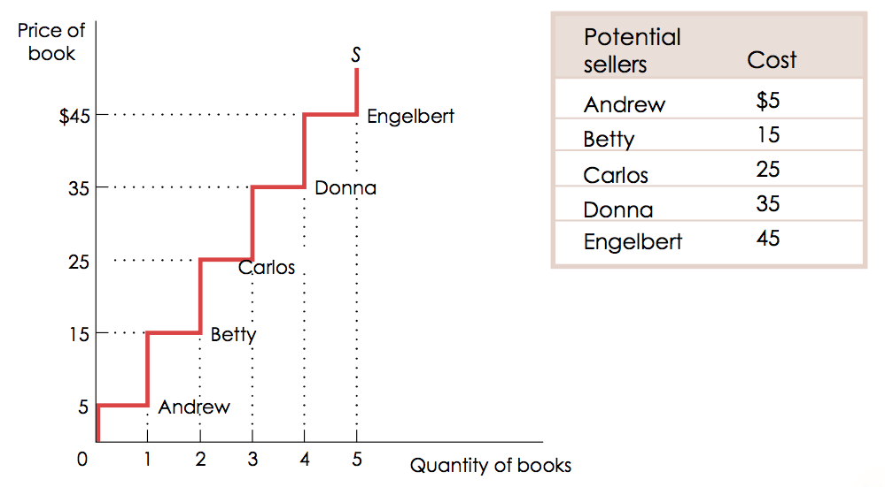

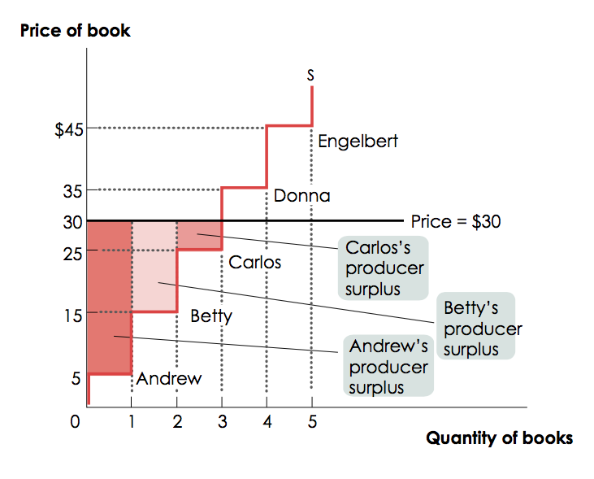

The total producer surplus from sales of a good at a given price is the area above the supply curve but below that price. In general, producer surplus rises if the price increases. The sum of consumer and producer surplus is known as the total surplus generated in a market.

One of the 12 core principles of economics is that markets are a remarkably effective way to organise economic activity. They generally make societies as well off as possible given the available resources.

But how does this connect to customer/producer surplus?

To answer this question, it is important to note that total surplus is maximised at market equilibrium, and both consumers and producers gain because there is a market for the given good.

There are some ways in which you might (unsuccessfully) try to increase the total surplus:

1. Reallocate consumption among consumers

This option lowers consumer surplus

1. Reallocate sales among sellers

This option lowers producer surplus

1. Change the quantity traded

This option lowers total surplus

These three options reduce the efficiency obtained with market equilibrium: markets are efficient! Once the market is in equilibrium, there is no way to increase the gains from trade.

The Characteristics of a Competitive Market

A competitive market is efficient when:

1. It reallocates the consumption of the good to the potential buyers who value it the most, as indicated by the fact that they have the highest willingness to pay.
2. It reallocates sales to the potential sellers who most value the right to sell the good, as indicated by the fact that they have the lowest cost.
3. It ensures that every consumer who makes a purchase values the good more than every seller who makes a sale, so that all transactions are mutually beneficial.
4. It ensures that every potential buyer who doesn’t make a purchase values the good less than every potential seller who doesn’t make a sale, so that no mutually beneficial transactions are missed.

In reality, consumers and producers do not make decisions in isolated markets (e.g.: a student’s decision in the market for used textbooks might be affected by how much interest must be paid on a student loan). The student’s decision in the used textbook market is influenced by what is going on in the market for money.

An efficient market equilibrium maximises total surplus – the gains to buyers and sellers in that market. When each and every market in the economy maximises total surplus, then the economy as a whole is efficient. The theoretical result of this is that it is virtually impossible to find an economy in which every market is efficient.

Well-functioning markets are effective because of:

1. Property Rights

System in which valuable items in the economy have specific owners who can dispose of them. In a system of property rights, by purchasing a good you receive “ownership rights”.

Property rights are what make the mutually beneficial transactions in any market possible. They create and protect incentives to trade with others and to innovate

1. Economic Signals

Any piece of information that helps people and businesses make better economic decisions (e.g.: prices).

Equilibrium prices signal to resources exactly where they are most valued: they convey information about other people’s cost and their willingness to pay. Prices translate complex information into an easy signal for producers:

* Profits rise in industries when consumers want more of that industry’s products.
* Profits decline in industries when consumers want less of that industry’s products.

However, there are three caveats when considering the efficiency of markets:

1. Although a market may be efficient, it isn’t necessarily fair.
2. Markets sometimes fail: when this occurs, markets no longer maximise total surplus
3. Government interventions in the market can reduce efficiency (see price controls, quotas and taxes)

Efficiency is important, but society also cares about equity. Sometimes societies choose to have governments intervene in markets to increase equity (even though it reduces efficiency).

Markets aren’t always efficient, however; sometimes they fail. The efficiency of a market is scaled according to the Pareto efficiency. Pareto efficiency requires that resources be allocated so that nobody could be made better of without making other people worse off. Markets are deemed inefficient when opportunities are missed. Some people could be made better off without making other people worse off.

Thus, market failures relate to the absence of one or more necessary conditions for competition so that the market cannot reach Pareto efficiency. This concept is consistent with the idea that if markets are competitive, there is no need for public intervention. This is the prevalent view, but not the only one:

1. Government failures

In attempting to correct failures the public sector creates additional sources of inefficiency. There are two schools of thought regarding this type of failure:

* Austrian School

Market failures don’t exist. Absence of competition brings up opportunities to individuals to make themselves better off. Market imperfections drive entrepreneurship and competition to improve market outcomes.

* Public Choice

Even if non-competitive markets are inefficient, public intervention would produce additional sources of inefficiency (essentially due to the role of bureaucrats, politicians, interest groups).

1. Transaction costs

Market failures depend on the existence of transaction costs. The government should not correct failures directly and instead reduce transaction costs.

1. Theory of the second best

Markets interaction makes failures correction potentially warping. Actions to improve efficiency in a sector may reduce overall efficiency.

1. Marxist economics

The notion of market failure is nonsense, as the market mechanism based on prices and property rights is structurally inconsistent with some necessary goals of a society such as equality, and a democratic mechanism to make decisions on production.

Market failures largely occur due to:

1. Market power

Firms (or, theoretically consumers) are price-makers. And may exploit their position to get extra profits, reducing other agents’ welfare (e.g.: monopoly and oligopoly).

1. Asymmetric information

The information set of one of the two parts of a transaction is incomplete (before or after transaction occurs). Asymmetric information can also be information about a good that some people possess but others don’t (e.g.: the market for “lemons”). Let’s demonstrate this example:

* Purchasers and suppliers have different information about the quality of the goods being sold (The Market for Lemons)
* There are 100 people who want to sell their cars and 100 people who want to buy a car
* Everyone knows that 50 cars are “plums” (good cars) and 50 cars are “lemons” (bad cars)
* The current owner of each car knows its quality but the perspective purchasers do not know whether any given car is a plum or a lemon
* The owner of a lemon is willing to sell it for $1000 and the owner of a plum is willing to sell it for $2000
* The buyers of the car are willing to pay $2400 for a plum and $1200 for a lemon
* If it is easy to verify the quality of the cars there will be no problems in this market. The plums will be sold at some price between $2000 and $2400 and the lemons at some price between $1000 and $1200

But what happens to the market if the buyers cannot observe the quality of the car? In this case the buyers have to guess about how much each car is worth. We assume that, if a car is equally likely to be a plum or a lemon, then typical buyer would be willing to pay the expected value of the car. Using the numbers described above, this means that the buyer would be willing to pay (1/2)\*1200+(1/2)\*2400=$1800. But who would be willing to sell their car at that price?

The owners of the lemons certainly would, but the owners of the plums wouldn’t be willing to sell their cars – by assumption they need at least $2000 to part with their cars. The price that the buyers are willing to pay for an “average” car is less than the price that the sellers of the plums want in order to part with their cars. This means that at the price of $1800 only lemons will be offered for sale.

But if the buyer was certain that he would get a lemon, then he would not be willing to pay $1800 for it. In fact, the equilibrium price in this market would have to be somewhere between $1000 and $1200. For a price in this range only owners of lemons would offer their cars. Even though the price at which buyers are willing to buy plums exceeds the price at which sellers are willing to sell them, no such transactions will take place.

Why does this market failure occur?

Because of quality uncertainty jointly with asymmetric information leading to adverse selection. Adverse selection refers to asymmetric information occurring before the transaction due to hidden information. As shown by Akerlof, it may lead eventually to the collapse of market.

A different kind of asymmetric information is known as moral hazard. It occurs after the transaction due to hidden action, when one of the two party has incentive to behave in contrast with the agreement, i.e. increasing the exposure to a risk (e.g. insurance).

1. Specific features of goods

External effects/Externalities and public goods.

Externalities are when the actions of individuals sometimes have side effects on the welfare of others that markets do not take into account (e.g.: pollution). Externalities can be produced by consumption or production, and they can either be positive or negative:

* POSITIVE = result in underproduction/consumption of a good or service
* NEGATIVE = result in overproduction/consumption of a good or service

Externalities refer to the existence of external benefits or costs that are not taken into account by agents so that the social benefit (or cost) differs from the private benefit (or cost).

Essentially, the problem here is the lack or property rights, and thus the non-existence of markets. There are several potential solutions to this:

1. PRIVATE SOLUTIONS (COASE’S THEOREM)

Imagine a firm discharging pollutant stuff into a river. Fishermen down the river would fish some weird fishes with 3 eyes. The problem is the nobody has the property right on the river. Let’s assign the property to the fishermen. Now the firm either stop the activity or pay an amount of money to fishermen to have the right to pollute. Does it work if we assign the rights to the polluter?

1. PUBLIC SOLUTIONS

* Pigouvian taxes

These set a tax on a unit of output. From polluter’s perspective taxes are additional costs. In turn, the polluter would reduce the quantity of output, thus reducing pollution. Does it work if instead of taxes we give subsidies to the polluter in exchange of a reduction of output quantity? Ethical Problems? Practical problems?

* Emission fees

These are taxes on units of pollution. The practical problems arise through cap and trade: permits are assigned to pollute and are traded freely.

1. Imperfect information and inter temporal choices

Consumers have not full information on the costs and benefits or they make choices that time inconsistent.

Types of Goods

MERIT GOODS

Merit goods are goods that are under-consumed because individuals undervalue the private benefit (demand is lower than it should be). The opposite is when consumers undervalue private costs (demerit), and demand is higher than it should be.

Merit goods can be connected with externalities just because very often merit (demerit) goods also produce positive (negative) externalities, but these two are completely different concepts:

1. EXTERNALITIES: refer to external effects
2. MERIT GOODS: refer to imperfect information and inter temporal choice

PUBLIC GOODS

Public goods are goods that are not provided by the market (or are under-provided) because there is no/little incentive for the private to produce/provide them. Some examples are national defence and lighthouses.

However, public goods are not necessarily produced by the public sector. Likewise, classification of a public good is not absolute and depends on market conditions/the state of technology.

To define a public good we should use the terms “excludable” and “non-rival”. Excludable means that preventing anyone from consuming the good is relatively easy. Non-rival, on the other hand, means that, once provided, the additional resource cost of another person consuming the good is zero.

Some public goods, however, can be impure: they might be partially rival (such as roads) and/or partially excludable (digital copies).

So what? if you cannot exclude someone from consumption of that good, you will not get revenues from producing it. In fact public goods are generally under-provided.

Technically, an efficient provision/production would be possible, but there is no incentive for individuals to pay for it, as it is not excludable (e.g.: Adam and Eve like fireworks. Adam does not declare he wants fireworks, knowing that Eve would buy them anyway. Once Eve bought fireworks, both Adam and Eve enjoy them).

This is called the free-rider problem: I can hide 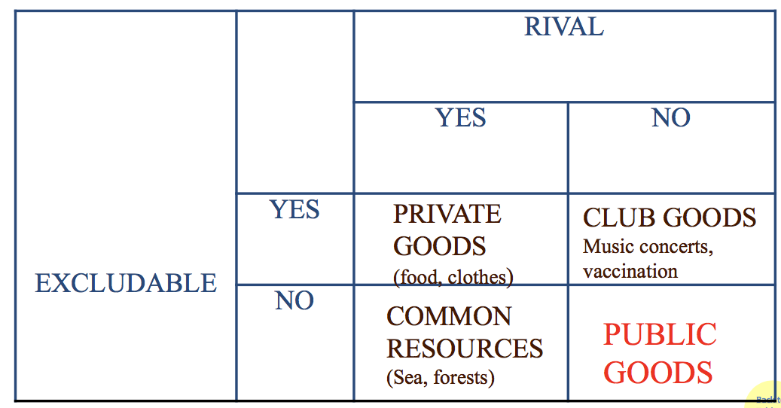my true willingness to pay and let the other individuals to pay for it, since I will consume the good anyway once it has been provided.

It’s a typical prisoner’s dilemma: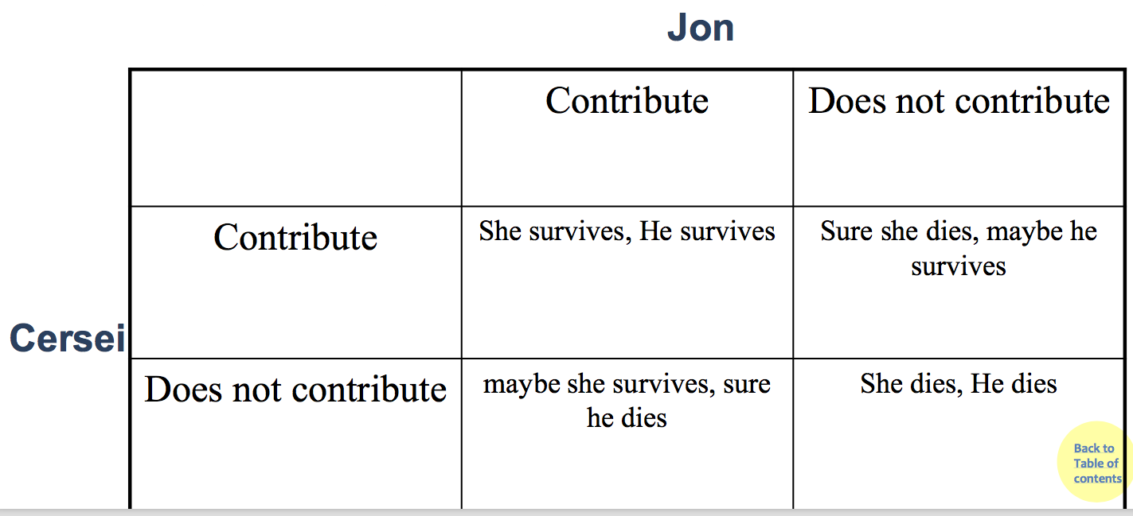

There are, however, some potential solutions:

1. Forced provision and forced payment (what if you do not like it?)

Taxes to finance the provision. It penalises those who don’t want to consume the good.

1. Openness

Everyone is told what everyone has contributed; experimental evidences show that it makes the difference

1. Punishment and/or reward

Contributors may punish the free-riders. But, what if no one punishes? Also, punishment-reward is costly and inefficient.

1. Threshold

If possible, the good is provided if and only if contributions cross a threshold: All-or-nothing public goods.

1. Tax concessions

To those who contribute.

1. Voting

Forced contribution if the majority vote for having the public good.

Price Controls and Quotas

Interference in markets has foreseeable consequences; distorted price signals cause resources to be misallocated. And if prices are distorted, they cannot give good information to buyers and sellers.

PRICE CONTROLS

Price controls are legal restrictions on how high or low a market price may go. There are two main types:

1. Price ceiling

A maximum price sellers are allowed to charge for a good or service (usually set below equilibrium).

Price ceilings cause predictable side effects:

* A persistent shortage of the good (effect on quantity)
* Inefficiency arising from this persistent shortage in the form of inefficiently low quantity (deadweight loss), inefficient allocation of the good to consumers, resources wasted in searching for the good, and the inefficiently low quality of the good offered for sale
* The emergence of illegal, black market activity

A price ceiling, ultimately, causes inefficiently low quantity of a certain good. So why do they exist? hey do benefit some people, such as low income tenants.

1. Price floor

A minimum price buyers are required to pay for a good or service (usually set above equilibrium). Sometimes governments intervene to push market prices up instead of down, and this is the case with the price floor.

Price floors cause predictable side effects:

* Deadweight loss from inefficiently low quantity
* Inefficient allocation of sales among sellers
* Wasted resources
* Inefficiently high quality
* Temptation to break the law by selling below the legal price

A price floor, like a price ceiling, causes inefficiently low quantity. They misallocate sales by:

* Allowing high-cost firms to operate
* Preventing low-cost firms from entering the industry

Why are there price floors, then?

* They do benefit some people, such as workers (minimum wage)
* If the market is not competitive just because employers have some market power, the equilibrium without ceiling would not be efficient and a minimum wage would in fact increase wages and employment
* Low income individuals have higher propensity to consumption than rich ones. Redistributing resources to them would have positive effects on the economy

If a price floor is set below equilibrium, it will have no effect (called non-binding). Only a price floor that forces price above equilibrium will have any effect (binding, or effective).

-.-

When prices are held below the market price, shortages are created. The lower the controlled price relative to the market equilibrium price, the larger the shortage.

Price controls also cause losses known as deadweight loss. This is the loss in total surplus that occurs whenever an action or a policy reduces the quantity transacted below the efficient market equilibrium quantity.

INEFFICIENT ALLOCATION TO CUSTOMERS

Price controls distort signals that would help the goods get allocated their highest-valued uses. Consumers who value a good most don’t necessarily get it, so producers have no incentive to supply the good to the “right” people first. As a result, goods are misallocated.

WASTED RESOURCES

Price controls that create shortages, such as price ceilings, lead to bribery and wasteful lines. During shortages, not all buyers will be able to purchase the good. Normally, buyers would compete with each other by offering a higher price. If the price is not allowed to rise, buyers must compete in other ways (waiting in line, illegal bribes and favours).

Price floors, on the other hand, encourage waste. To deal with the surplus generated by agricultural price floors, the U.S. government sometimes buys back the excess and donates or destroys it.

INEFFICIENTLY LOW QUALITY

At a controlled price, sellers have more customers than goods. In a free market, this would be an opportunity to profit by raising prices. But when prices are controlled, sellers cannot. Sellers respond to this problem in two ways:

1. Reduce quality
2. Reduce service

BLACK MARKETS

A black market is a market in which goods or services are bought and sold illegally — either because they are prohibited or because the equilibrium price is illegal. Price floors encourage black markets. There are willing sellers (and buyers) at illegal prices, so they are tempted to break the law and trade with each other.

-.-

CONTROLLING QUANTITIES

Governments sometimes control quantity instead of price:

1. Quota

This is an upper limit, set by the government, on the quantity of some good that can be bought or sold; also referred to as a quantity control

1. Quota limit

The total amount of a good under a quota or quantity control that can be legally transacted

1. License

The right, conferred by the government, to supply a good

THE COSTS OF QUANTITY CONTROL

Like price controls, quotes impose losses on society:

1. Deadweight loss
2. Incentives for legal activities

Elasticity

A demand curve is elastic when an increase in price reduces the quantity demanded a lot (and vice-versa). When the same increase in price reduces quantity demanded just a little, then the demand curve is inelastic.

The more responsive quantity demanded is to a change in price, the more elastic is the demand curve. Elasticity is different from a slope, but if two linear demand/supply curves run through a common point, then at any given quantity, the curve that is flatter is more elastic.

DEFINING AND MEASURING ELASTICITY

Price elasticity of demand is the percentage change in quantity demanded divided by the percentage change in price: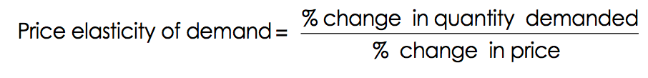

For example:

If the price of oil increases by 10% and the quantity demanded falls by 5%, then the price elasticity of demand for oil is: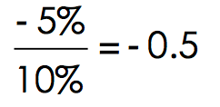

But since we know that price and quantity demanded will always move in opposite directions (law of demand) we usually drop the minus sign (only for price elasticity of demand.

USING THE MIDPOINT FORMULA

There’s a problem: our percent change calculation depends on our choice of starting point. To solve this problem, we calculate the price elasticity of demand using the midpoint formula for percentage changes: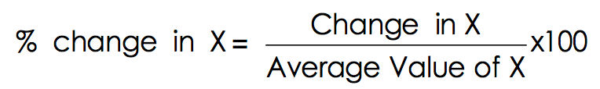

Where: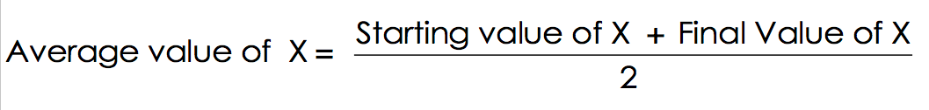

ESTIMATING ELASTICITIES

Economists (and many others) are interested in price elasticity of demand. Estimating elasticity is crucial to understanding and predicting market outcomes.

Price elasticity of demand can be classified since it can be as low as zero or as high as infinity:

1. If the |Ed| < 1, the demand curve is inelastic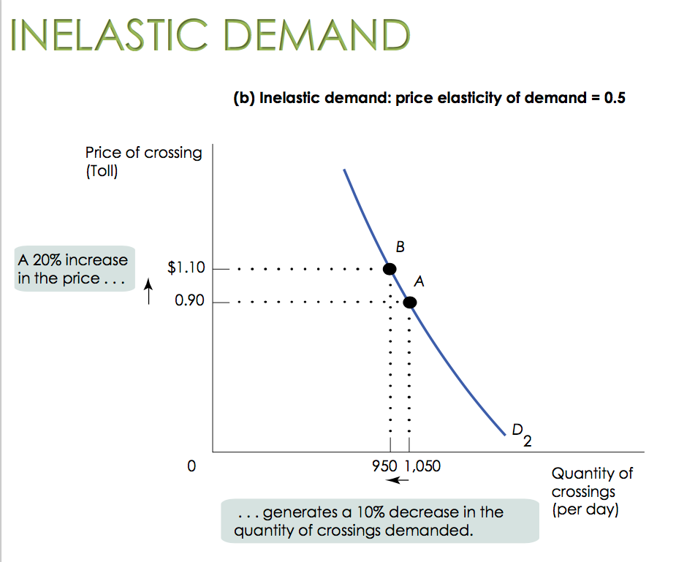

When demand is inelastic, the price effect dominates the quantity effect. So an increase in price will cause only a slight reduction in the quantity demanded. In this instance, total revenue will rise when the price rises (and vice-versa).

1. If the |Ed| > 1, the demand curve is elastic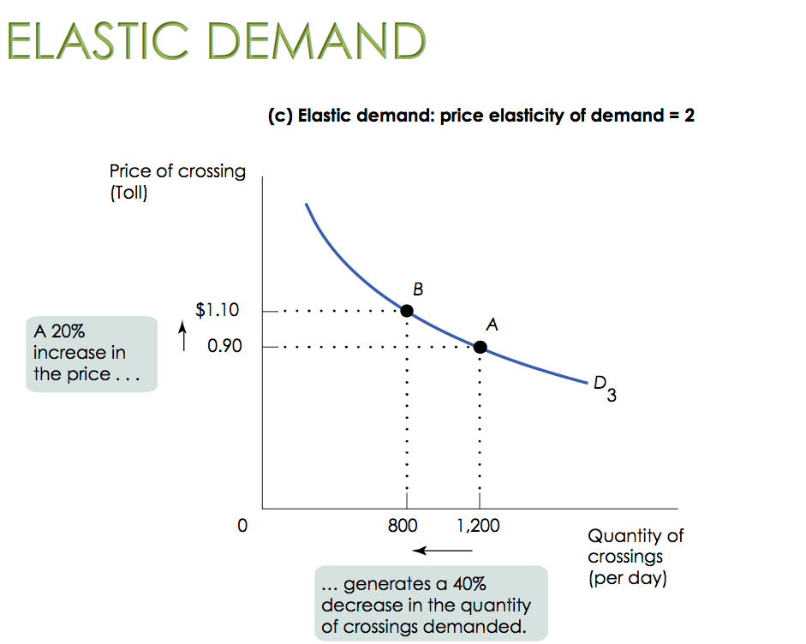

When demand is elastic, the quantity effect dominates the price effect. So an increase in price will cause significant reduction in the quantity demanded. In this instance, total revenue will fall when the price rises (and vice-versa).

1. If the |Ed| = 1, the demand curve is unit elastic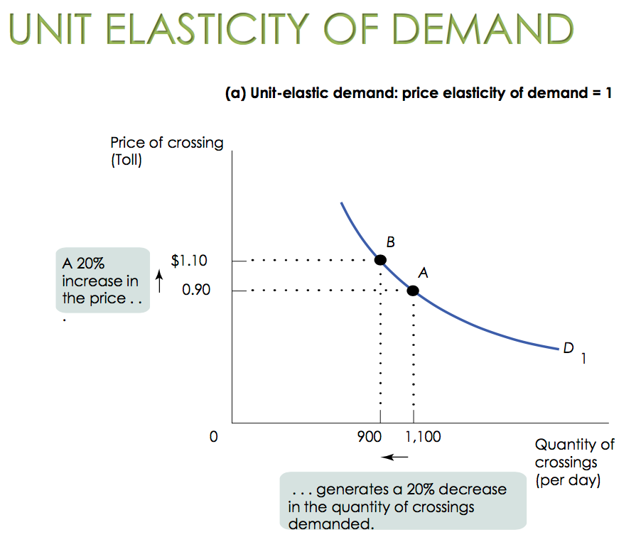

When demand is unit-elastic, the quantity effect equals the price effect. So an increase in price balances the reduction in the quantity demanded. In this instance, total revenue doesn’t change.

It can also be extremely low:

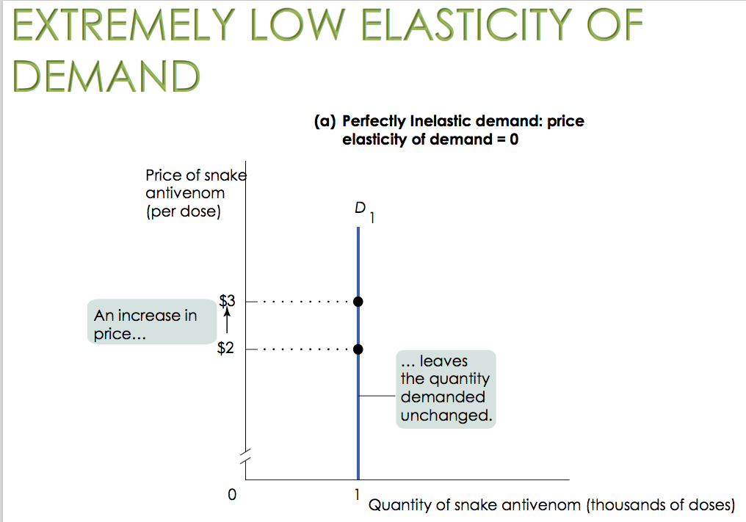

Or extremely high:

ELASTICITY AND TOTAL REVENUE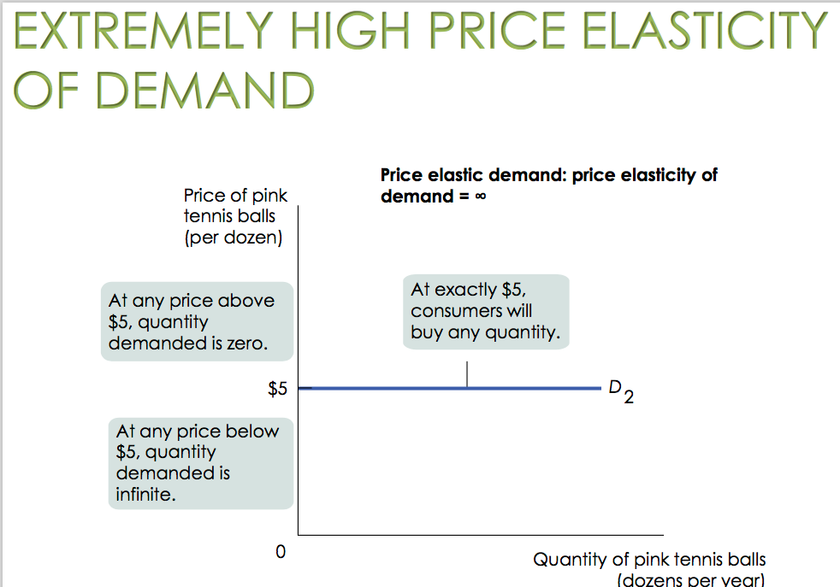

Total revenue is price times quantity demanded (sold), so:

TR = P x Q

Sellers need to know how elastic their good is so they can plan.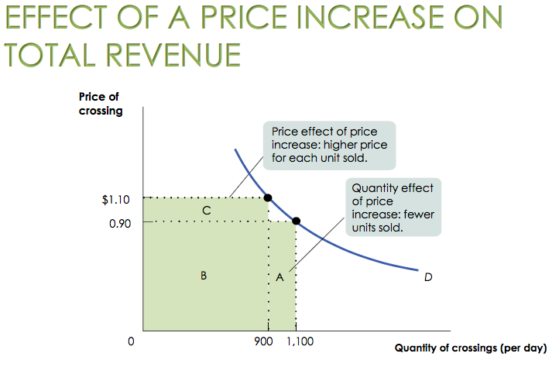

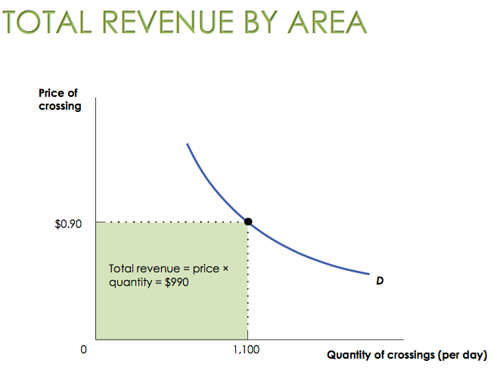

WHAT FACTORS DETERMINE THE PRICE ELASTICITY OF DEMAND?

1. The availability of close substitutes is important

Fewer substitutes makes it harder for consumers to adjust Q when P changes, so demand is inelastic. Switching brands when prices change is easy, so demand is elastic.

1. The share of income spent on the good matters

We are less sensitive to price changes when the good feels cheap. We are more sensitive to price changes when the good feels expensive.

1. The length of time elapsed since the price change matters

Less time to adjust means lower elasticity. Over time. Consumers can adjust their behaviour by finding substitutes (making demand more elastic).

INCOME ELASTICITY OF DEMAND

The income elasticity of demand measures how sensitive the quantity demanded of a good is to changes in income. Income elasticity of demand can be calculated as: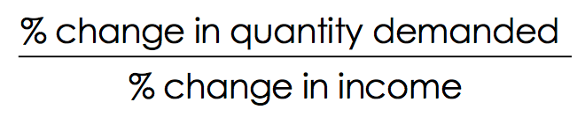

The income elasticity of demand can be used to distinguish normal form inferior goods:

1. Normal goods = income elasticity is positive
2. Inferior goods = income elasticity is negative

Normal goods can either be income-elastic or inelastic.

For income-elastic goods, income elasticity is greater than 1 (luxury goods, international travels, etc.).

For income-inelastic goods, income elasticity is positive, but less than 1 (necessities such as food and clothing).

PRICE ELASTICITY OF SUPPLY

Usually, sellers offer more when prices are higher, but how strong is that relationship, exactly? Measuring the price elasticity of supply is similar to the demand formula: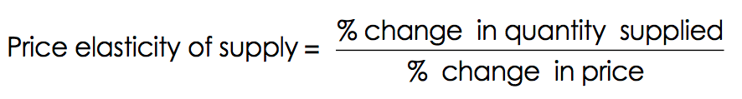

A supply curve is elastic if a rise in price increases the quantity supplied by a lot (and vice-versa). It’s inelastic if sellers change quantity just by a little.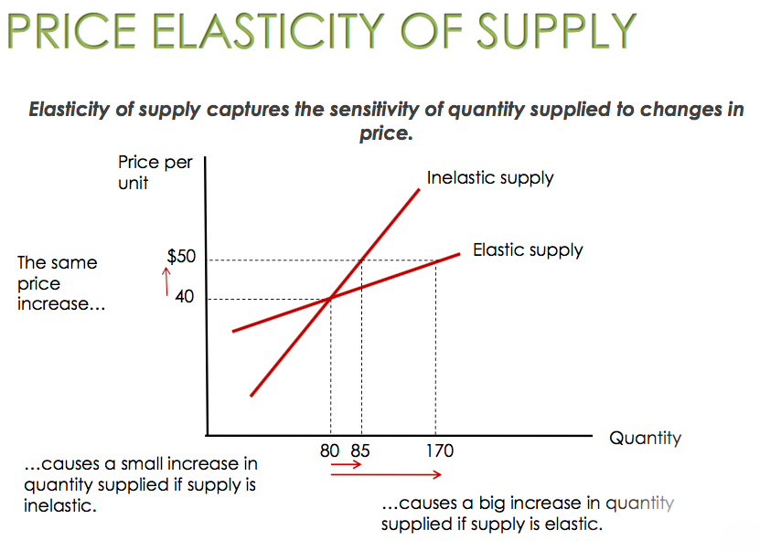

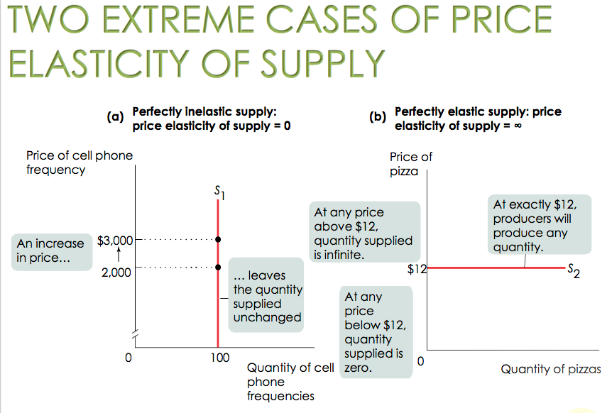

WHAT FACTORS DETERMINE THE PRICE ELASTICITY OF SUPPLY?

1. Availability of inputs

If increased production is very expensive, then the supply curve will be inelastic. If production can be increased cheaply, then the supply curve will be elastic.

1. Time

Price elasticity of supply increases as producers have more time to respond to price changes. Long-run price elasticity of supply is usually higher than the short-run elasticity.

Taxes

Excise taxes are “per unit” of the good (one packet of cigarettes, one bottle of wine). Taxes in percentage of the price or in percentage of the value are called ad valorem, like the Value Added Tax (V.A.T.) which is the sale tax imposed on goods and service in all countries. In Italy, we have Imposta sul Valore Aggiunto (IVA).

THE EFFECTS OF AN EXCISE TAX ON QUANTITIES AND PRICES

Taxes drive a wedge between the price buyers pay and the price sellers receive. To analyse the effects, we’ll graph two scenarios:

1. When the tax is levied on sellers
2. When the tax is levied on buyers

The incidence of a tax is a measure of who really pays it.

THE BENEFITS AND COSTS OF TAXATION

* The positive effects of tax rate cuts on the size of the economy arise because lower tax rates raise the after-tax reward to working, saving, and investing. These higher after-tax rewards induce more work effort, saving, and investment through substitution effects.
* The costs are:

1. Administrative costs = the cost of having a tax administration
2. Compliance costs = the costs imposed on the taxpayer to comply with the law
3. The regular deadweight loss = the inefficiency caused by reallocation of activities by taxpayers who switch to non-taxed activities
4. The excess burden of tax evasion = the risk borne by taxpayers who are evading
5. Avoidance costs = the cost incurred by a taxpayer who searches for legal means to reduce tax liability.

THE REVENUE FROM AN EXCISE TAX

The tax increase affects tax revenue in two ways:

1. The tax increase means that the government raises more revenue for each unit of the good sold (this leads to a rise in tax revenue)
2. The tax increase reduces the quantity of sales (this leads to a fall in tax revenue)

The end result depends on the price elasticity of demand and supply and on the initial level of tax. If the price elasticity of both demand and supply is low, the tax’s increase won’t reduce the quantity of the good sold very much, so tax revenue will definitely rise.

If the price elasticity is high, the result is less certain. If the initial tax rate is low, the government does not lose much revenue from the decline in the quantity of the good sold, so the tax increase will definitely increase tax revenue. If the initial rate is high, the result is less certain.

DEADWEIGHT LOSS AND ELASTICITIES

If the goal in tax policy is efficiency (minimising deadweight loss), then policymakers should choose the goods with the lowest price elasticities.

TAX FAIRNESS AND TAX EFFICIENCY

There are two principles related to tax fairness:

1. The benefits principle

Those who benefit from public spending should bear the burden of the tax that pays for that spending.

1. The ability-to-pay principle

Those with greater ability to pay a tax should pay more tax.

There is usually a trade-off between equity and efficiency: the system can be made more efficient only by making it less fair, and vice versa.

UNDERSTANDING THE TAX SYSTEM

1. Lump-sum tax

This is the same for everyone, regardless of any actions people take.

1. Income tax

This depends on income from wages and investments.

1. Payroll tax

This depends on the earnings an employer pays to an employee (contributions for pensions).

1. Sales tax

This depends on the value of goods sold.

1. Profits tax

This depends on a firm’s profit.

1. Property tax

This depends on the value of property, such as a home.

1. Wealth tax

A tax that depends on an individual’s wealth.

1. Tax structure

This specifies how the tax depends on the tax base.

1. Progressive tax

This takes a larger share of the income of high-income taxpayers than of low- income taxpayers.

1. Regressive tax

This takes a smaller share of the income of high-income taxpayers than of low- income taxpayers.

1. Marginal tax rate

This is the percentage of an increase in income that is taxed away.

Decision-making

Our decisions on the market tend to depend on comparing costs to benefits, and the quality of the decisions depends on how well we understand costs and benefits.

There are different types of costs:

1. EXPLICIT COSTS

Explicit costs are costs that require an outlay of money (e.g.: the cost of books).

1. IMPLICIT COSTS

These do not require of outlay of money and are measured by the value (in dollar terms) of benefits that are forgone (e.g.: wages forgone because of being a full-time student).

Profit can also be divided into two types:

1. ECONOMIC PROFIT

An economic profit or loss is the difference between the revenue received from the sale of an output and the costs of all inputs used, as well as any opportunity costs. In calculating economic profit, opportunity costs and explicit costs are deducted from revenues earned.

Economic profit equals revenue minus the opportunity cost of all resources used, and is usually less than accounting profit. It shows a more complete picture of costs and helps businesses and individuals make better-informed decisions. This is the measure economists prefer.

It can be calculated as:

Economic profit = revenue - explicit cost - implicit cost

1. ACCOUNTING PROFIT

This is known as total earnings and is calculated according to generally accepted accounting principles (GAAP). It includes the explicit costs of doing business, such as operating expenses, depreciation, interest, and taxes.

It can be calculated as:

Accounting profit = revenue - explicit cost

CAPITAL

What is capital? Capital is the total value of assets owned by an individual/firm, that is:

Physical assets + Financial assets

The implicit cost of capital is the opportunity cost of the use of one’s own capital, meaning the income earned if the capital had been employed in its next best alternative use (e.g.: forgone interest income).

DECISION-MAKING

There are two different types of decisions that need to be made in economics:

1. EITHER-OR

When faced with a choice between two activities, we must choose the one with the positive economic profit.

1. HOW MUCH?

This decision requires weighing the additional costs and benefits of each increase. In this field of decision-making, marginal cost is the additional cost incurred by producing one more unit of that good or service.

THE SHAPE OF MARGINAL COST

The marginal cost curve shows how the cost of producing one more unit depends on there quantity that has already been produced. It refers to the increase or decrease in the cost of producing one more unit or serving one more customer. It is also known as incremental cost.

Although each product has a unique marginal cost, some basic shapes include:

* Increasing marginal cost

Each additional unit costs more to produce than the previous one.

* Constant marginal cost

Each additional unit costs the same to produce as the previous one.

* Decreasing marginal cost

Each additional unit costs less to produce than the previous one.

Thus, we can conclude that marginal cost and total cost must always move in the same direction. If marginal cost of producing the first widget is $5, the second $4, and the third $3, total cost rises as marginal cost falls.

MARGINAL BENEFIT

Marginal benefit is the additional benefit derived from producing one more unit of a good or service. It is the maximum amount a consumer will pay for an additional good or service. A marginal benefit is also the additional satisfaction that a consumer receives when the additional good or service is purchased. The marginal benefit generally decreases as consumption increases.

MARGINAL ANALYSIS

This is the examination of the additional benefits of an activity compared to the additional costs incurred by that same activity. Companies might use marginal analysis as a decision-making tool to help them maximise their potential profits.

For a profit-maximising “how much” decision, the optimal quantity is the largest quantity at which the marginal benefit is greater than or equal to marginal cost. This has a pitfall: what we are doing here is setting the marginal benefit and cost equal to each other, and not maximising the total difference between benefits and costs.

SUNK COSTS

A sunk cost is a cost that has already been incurred and is not recoverable. It should be ignored in decisions about future actions, albeit this is sometimes quite hard to do. An example is, if you lose your concert tickets, the $80 you’ve already spent on them — it is a sunk cost.

BEHAVIOURAL ECONOMICS

Are there limits to human rationality in decision-making and choosing the right option? There are three reasons as to why humans would rationally choose a worse payoff:

1. CONCERNS ABOUT FAIRNESS

Providing others sometimes trumps self-interest.

1. BOUNDED RATIONALITY (“GOOD ENOUGH”)

Making a choice that is close to the highest possible profit may make sense because the effort of finding the best payoff is too costly.

1. RISK AVERSION

Willingness to sacrifice some economic payoff in order to avoid a potential loss is also fairly common.

In economics, an irrational decision-maker chooses an option that leaves them worse off than choosing another available option. These holes in our rationality stem from seven established decision-making mistakes:

1. MISPERCEIVING OPPORTUNITY COSTS

If we don’t understand all the costs, we cannot make a rational choice.

1. BEING OVERCONFIDENT

We might have the illusion of control, or our planning might be quite fallacious.

1. HAVING UNREALISTIC EXPECTATIONS ABOUT FUTURE BEHAVIOUR

Most of us are overly optimistic about our future behaviour and level of discipline.

1. COUNTING DOLLARS UNEQUALLY

This refers to the habit of mentally assigning dollars to different accounts so that some dollars are worth more than others (e.g.: spending more with credit cards than cash).

1. BEING LOSS-AVERSE

Loss aversion is an oversensitivity to loss that leads to unwillingness to recognise a loss and move on.

1. HAVING A BIAS TOWARDS THE STATUS-QUO

This is the tendency to avoid making a decision altogether.

1. FRAMING EFFECT

The framing effect is a cognitive bias where people decide on options based on whether the options are presented with positive or negative connotations; e.g. as a loss or as a gain. People tend to avoid risk when a positive frame is presented but seek risks when a negative frame is presented.

Optimal Consumption

Rational consumers choose what to spend their money on depending on their preferences and their budget constraints. Given their consumption bundle, a consumer’s total utility changes according to:

1. INDIFFERENCE CURVES

An Indifference Curve is the set of all baskets for which the consumer is indifferent, and an Indifference Map illustrates the set of indifference curves for a particular consumer.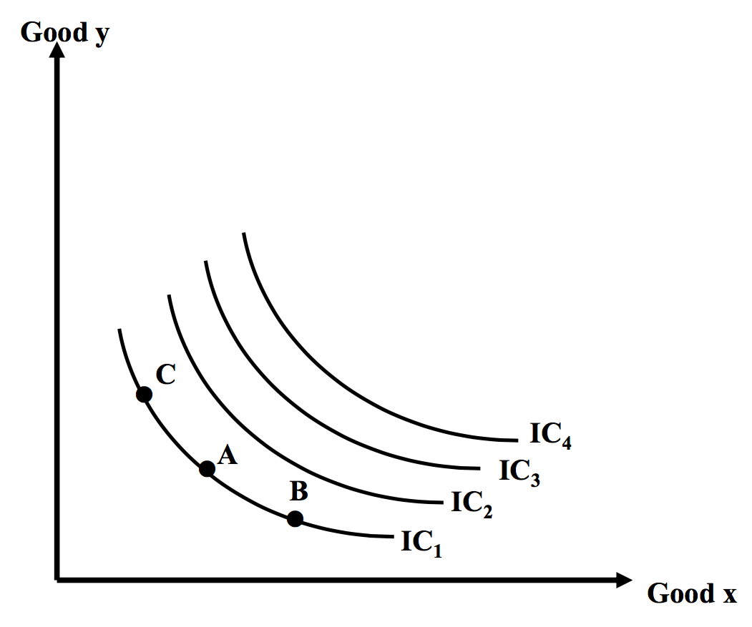

Indifference curves have very specific properties:

* They never cross (because, by definition, the consumer is indifferent)
* The further out a curve lies, the higher the level of total utility
* They slope downward
* They have a convex shape

1. THE MARGINAL RATE OF SUBSTITUTION

This is the negative of the slope of the indifference curve, and can be calculated as:

MRSx,y = - (dy/dx)

The MRS is the psychological and individual-specific measure of the relative value of two commodities.

An indifference curve in particular exhibits a diminishing marginal rate of substitution, meaning that, the more of good X you have, the more you are willing to give up to get a little bit of good Y. Indifference curves:

* Get flatter as we move out along the horizontal axis
* Get steeper as we move up along the vertical axis

1. THE UTILITY FUNCTION

The utility function measures the level of satisfaction that a consumer receives from any basket of goods. It assigns a number to each basket; most-preferred baskets get a higher number than less-preferred baskets. Utility is naturally an ordinal concept, meaning that the precise magnitude of the number that the function assigns has no significance.

Ordinal ranking gives information about the order in which a consumer ranks baskets. The implications of an ordinal utility function are:

* Difference in magnitudes of utility have no interpretation per se
* Utility is not comparable across individuals
* Any transformation of a utility function that preserves the original ranking of bundles is an equally good representation of preferences

Cardinal ranking, on the other hand, gives information about the intensity of a consumer’s preferences. We can measure, for example, the strength of a consumer’s preference for yoghurt over apples.

Within the utility function, we can also talk about marginal utility. Marginal utility of good X is the additional utility that the consumer gets from consuming a little more of X, and this can be expressed as:

MUx = (dU/dX)

It is the derivative of the utility function with respect to X, and assumes that the consumption of all other goods in the consumer’s basket remain constant. According to the principle of diminishing marginal utility, the marginal utility of a good falls as consumption of that good increases.

The ratio of the marginal utilities of the goods in a basket can be expressed as MRSx,y (the Marginal Rate of Substitution). Supposing the consumer changes the levels of consumption of x and y, we can use differentials:

dU = MUx . dX + May . dY

Along a particular indifference curve, dU = 0, so:

0 = MUx . dX + MUy . dY

Solving for dY/dX:

- (dY/dX) = (MUx/MUy)

Since MRSx,y = - (dY/dX)

Thus, the slope of the indifference curve is:

MRSx,y = (MUx/MUy)

Diminishing marginal utility implies the indifference curves are convex to the origin (implies averages preferred to extremes). For example:

U = (xy)^0.5

MUx = y^0.5/2x^0.5

MUy = x^0.5/2y^0.5

Here, marginal utility is positive for both goods, and averages are preferable to extremes in the case where marginal utility diminishes for both goods. Here, the Marginal Rate of Substitution is:

MRSx,y = (MUx/MUy) = (y/x)

THE BUDGET CONSTRAINT

The budget constraint shows all of the consumption bundles that a consumer can afford given their income snd the prices. If income = $100, Pgas (Px) = $2, and Ppizza (Py) = $10, we can figure out our consumption possibilities. Thus, the slope of the budget line is -Px/Py, representing the market relative value of the two goods. An increase in income intuitively shifts the budget constraint outward.

HOW TO COMPARE APPLES AND ORANGES/PIZZA AND GAS

How many gallons of gasoline? How many pizzas?

The answer depends on two specific variables (trade offs):

1. How much you like it (utility, which is PREFERENCES)
2. How much it costs (price, which is the BUDGET CONSTRAINT)

Since most decisions are made at the margin, we’ll need to know:

1. How much extra utility (MU) will you get from spending your next dollar on gasoline?
2. On pizza?

Remember: we are looking to maximise the utility per dollar spent. As a general rule, it’s crucial that we adjust our spending towards the goods that give us more MU per dollar by comparing the MU and the price for all goods.

If MUgas/Pgas > MUpizza/Ppizza, then buy more gasoline, as, dollar for dollar, it makes you happier than pizzas.

OPTIMAL CONSUMPTION BUNDLE

If, however, MUpizza/Ppizza > Mugas/Pgas, then buy more pizza. The optimal consumption bundle, overall, is always where:

MUa/Pa = MUb/Pb = … = MUz/Pz

By definition, the optimal consumption bundle is the one that maximises a consumer’s total utility given their budget constraint. The condition for an optimal consumption bundle, ultimately, is:

MUx/Px = MUy/Py

Or:

MUx/MUy = Px/Py

This last equation states that the psychological relative value of the goods must equal the objective market relative value of the two goods.

FROM UTILITY TO DEMAND CURVE

But how does the utility-maximising behaviour of individual consumers lead to the downward slope of the market demand curve?

Let’s suppose that the price of fried clams (Pc) rises. This price increase does not change the MU (marginal utility) a consumer gets from an additional unit of clam, MUc. It does, however, reduce the MU per dollar spent on clams, MUc/Pc.

This decrease in marginal utility per dollar spent on clams gives the consumer a incentive to consume fewer clams when the price of clams rises. Why is this? A utility-maximising consumer chooses a consumption bundle for which the marginal utility per dollar spent on all goods is the same. If the marginal utility per dollar spent on clams falls because the price of clams rises, the consumer can increase his or her utility by purchasing fewer clams and more of other goods.

To summarise: when the price of a good increases, an individual will consume less of that good and more of other gods. Consequently, when the price of a good decreases, an individual will normally consume more of that good and less of the other goods. This explains why the individual demand curve normally slopes downward. The market demand curve is the horizontal sum of all the individual demand curve of consumers.

THE SUBSTITUTION EFFECT

The substitution effect is the change in the quantity consumed of that good as the consumer substitutes the good that has become relatively cheaper for the good that has become relatively more expensive.

THE INCOME EFFECT

The income effect is the change in the quantity consumed of a good that results from a change in the consumer’s purchasing power due to the change in the price of the good.

With normal goods, an increase in price causes consumers’ purchasing power to drop and reduces consumption (and vice versa).

With inferior goods, an increase in price causes consumers’ purchasing power to drop and increases consumption (and vice versa).

GIFFEN GOODS

A giffen good is a hypothetical inferior good for which the income effect outweighs the substitution effect and the demand curve slopes upward. An example are Irish potatoes, which are an inferior good that took up so much of an average person’s income that when potato prices rose, purchasing power dropped and they had to eat more of all inferior goods.

Input and Costs

PRODUCTION

Production is the process of turning inputs into outputs, and the cost structure of a firm depends on the nature of the production process.

A production function is the relationship between a quantity of inputs a firm uses and the quantity of output it produces and underlies the cost curves of a firm’s production.

There are different types of inputs:

1. FIXED

This is an input whose quantity is fixed for a period and cannot be varied (land, costly machinery, etc.).

1. VARIABLE

This is an input whose quantity the firm can vary at any time (labor force in flexible labor markets).

Whether or not the quantity of an input is fixed depends on the time horizon:

1. THE LONG RUN

The period in which all inputs can be varied.

1. THE SHORT RUN

The period in which at least one input is fixed. Within this realm, a marginal product is the change in output resulting from a one-unit increase in the amount of labor input (ΔQ/ΔL). Marginal product initially rises as more workers are hired; then it declines.

In general, there are diminishing returns to an input when an increase in the quantity of that input, holding the quantity of all other inputs fixed, reduces that input’s marginal product. Due to diminishing returns to labor, the MPL curve is negatively sloped.

1. THE TOTAL PRODUCT CURVE

Shows how the quantity of output depends on the quantity of the variable input for a given quantity of the fixed input.

WHAT IS A UNIT?

The marginal product of labour (MPL) is defined as the increase in the quantity of output when you increase the quantity of that input by one unit. By a unit of labour, we don’t mean an additional hour of labour or a person-year, but consistency.

TOTAL PRODUCT, MARGINAL PRODUCT, AND FIXED INPUT

With more land (fixed input) each worker can produce more. This shifts the total product curve up. So the marginal product of labour (MPL) of each worker is higher when the farm is larger; the MPL curve also shifts up.

THE TYPES OF COST CURVES

There are essentially four types of cost curves:

1. FIXED COST CURVE

This is a cost that does not depend on the quantity of output produced. It is the cost of the fixed input.

1. VARIABLE COST CURVE

This is a cost that depends on the quantity of output produced. It is the cost of the variable input.

1. TOTAL COST CURVE

The total cost of producing a given quantity of output is the sum of the fixed cost and the variable cost of producing that quantity of output:

TC = FC + VC

The total cost curve becomes steeper as more output is produced, a result of diminishing returns.

1. MARGINAL COST CURVE

Marginal cost is the change in total cost generated by one additional unit of output:

MC = ΔTC/ΔQ (Δ= CHANGE, TC = total cost, Q = quantity of output)

The marginal cost curve it upward sloping because of diminishing returns; as output increases, the marginal product of the variable input declines. This implies that more and more of the variable input must be used to produce each additional unit of output as the amount of output already produced rises. Since each unit of the variable input must be paid for, the cost per additional unit of output also rises.

This curve intersects the average total cost curve from below, crossing at its lowest point.

1. AVERAGE COST CURVE

There are three types of average cost curve:

1. AVERAGE TOTAL COST/AVERAGE COST

Refers to the total cost per unit of output produced:

ATC = TC/Q

Increasing output has two opposing effects on average total cost:

* The larger the output, the more output over which fixed cost is spread, leading to lower average fixed cost (THE SPREADING EFFECT)
* The larger the output, the more variable input required to produce additional units, which leads to highe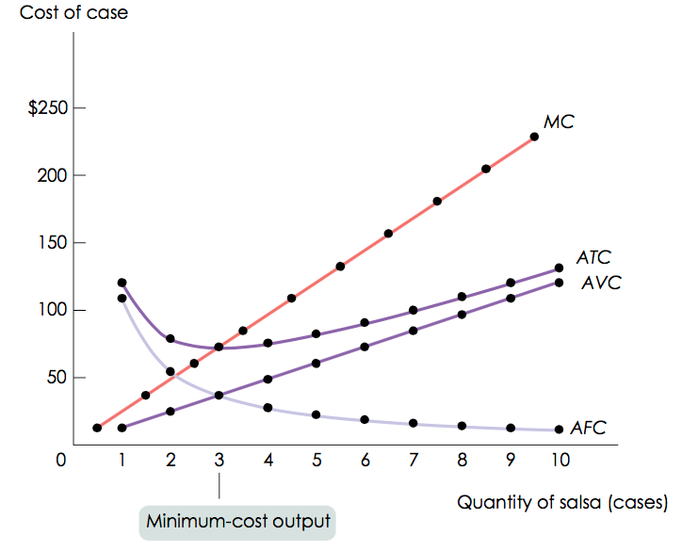r average variable cost (THE DIMINISHING RETURNS EFFECT)

1. AVERAGE FIXED COST

Refers to the fixed cost per unit of output produced:

AFC = FC/Q

This is downward sloping because of the spreading effect.

1. AVERAGE VARIABLE COST

Refers to the variable cost per unit of output produced:

AVC = VC/Q

This is upward sloping, but is flatter than the marginal cost curve.

The relationship between these is illustrated by the figures below:

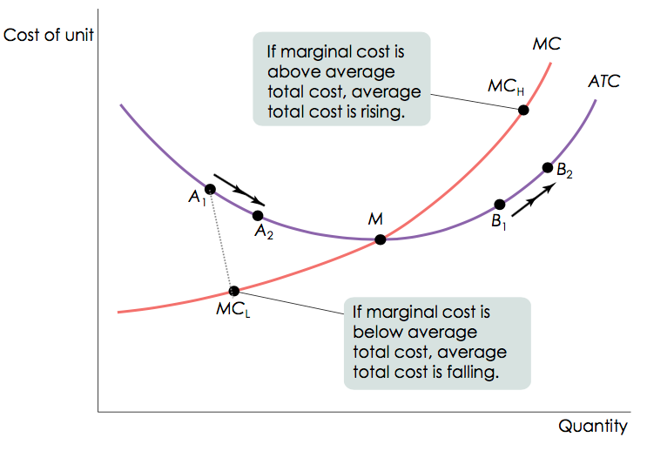

SHORT-RUN VS LONG-RUN COSTS

In the long run, all inputs are variables. This means that in the long run, fixed cost (like factory size) may also vary. The firm will choose its fixed cost in the long run based on the level of output it expects to produce.

THE LONG-RUN AVERAGE TOTAL COST CURVE

What is the relationship between short run and long run average total cost curve?

The long-run average total cost curve shows the relationship between output and average total cost when fixed cost has been chosen to minimise average total cost for each level of output.

RETURNS TO SCALE

There are increasing returns to scale (economies of scale) when long-run average total cost declines as output increases. There are decreasing returns to scale (diseconomies of scale) when long-run average total cost increases as output increases, and constant returns to scale when long-run average total cost is constant as output increases.

Models of Market Structure

In order to develop models and make predictions about how producers will behave, we have developed four principal models of market structure: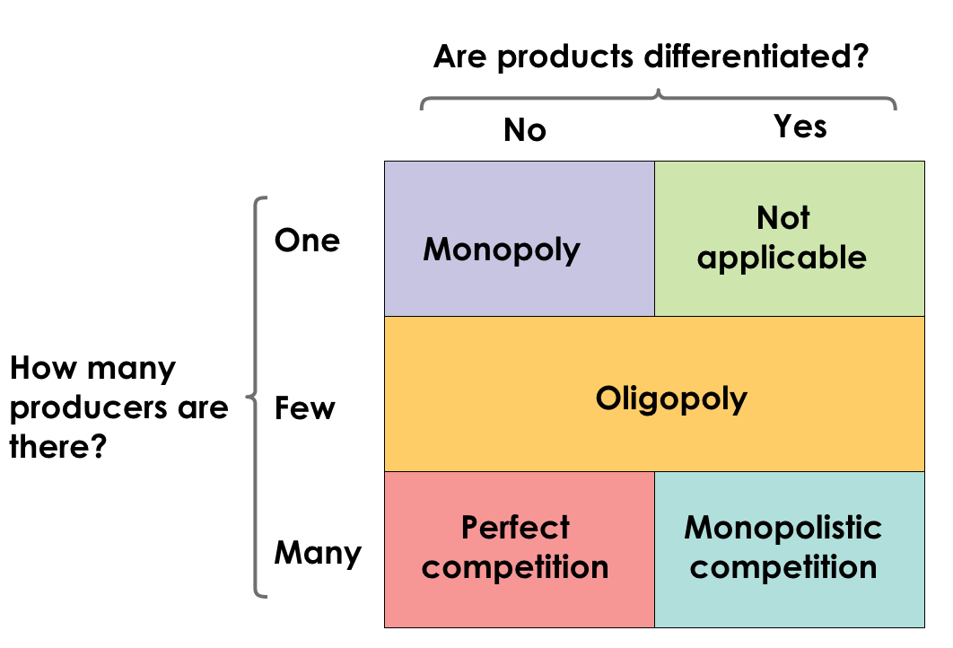

Perfect Competition

Perfect competition has some key characteristics we should pay attention to:

1. THERE ARE MANY BUYERS AND SELLERS, EACH WITH A SMALL MARKET SHARE

A market share is the fraction of the total industry output accounted for by that producer’s output. This means that both sellers and buyers are price-takers and their actions thus have no effect on price.

1. THE PRODUCT IS STANDARDISED ACROSS SELLERS

Consumers regard different sellers’ products as equivalent, and thus products are standardised and are commodities.

1. FREE ENTRY AND EXIT

New producers can easily enter into an industry and existing producers can easily leave that industry.

PRODUCTION AND PROFITS

Since each firm is a price-taker:

TR (each firm’s total revenue) = P (price) x Q (quantity sold)

And:

Profit = TR (total revenue) - TC (total cost)

MARGINAL REVENUE AND THE OPTIMAL OUTPUT RULE

Marginal revenue is the change in total revenue generated by an additional unit of output, so:

MR = ΔTR/ΔQ

For price-taking firms, MR is simply the good’s market price:

MR = ΔTR/ΔQ = (PxΔQ)/ΔQ

According to the optimal output rule, profit is maximised by producing the quantity of output at which the marginal revenue of the last unit produced is equal to its marginal cost.

Why is profit maximised when MR = MC? Because each time the firm produces another unit, there are extra costs and extra revenues. If producing another unit adds more to revenue than cost, profit will increase. If MR > MC, producing more will add to profit. If MR < MC, producing less will add to profit. The profit-maximising rule is to choose the quantity of output where P = MC.

WHEN IS PRODUCTION PROFITABLE?

Before applying the profit-maximising principle of marginal analysis to determine how much to produce, a potential producer must answer an “either-or” question: should it produce at all?

If the answer to that question is yes, it then proceeds to the second step – a “how much” decision: maximising profit by choosing the quantity of output at which marginal cost is equal to price.

A firm’s decision to produce or not should be based on economic profits:

* If TR > TC, the firm is profitable
* If TR = TC, the firm breaks even
* If TR < TC, the firm incurs a loss

CALCULATING TOTAL COSTS AND PROFIT

Profit can be expressed as either:

TR - TC = (TR/Q - TC/Q) x Q

Or:

(P - ATC) x Q

The break-even price of a price-taking firm is the market price at which it earns zero profit. In general:

* If the firm produces a quantity at which P > ATC, the firm is profitable
* If the firm produces a quantity at which P=ATC, the firm breaks even
* If the firm produces a quantity at which P<ATC, the firm incurs a loss

To summarise, if the price is just high enough to cover ATC, and if it chooses the Q where MR = MC, the firm will break even

LOSSES

Losses, however, don’t mean immediate shutdown, as fixed costs must be paid whether or not the firm produces in the short run. Firms will choose to produce (even at a loss) if they can cover their variable and some of their fixed costs, which can either be above or below the shut-down price (the minimum average variable cost).

So in the short run, a firm will only produce if P > shutdown price (min AVC), since if P > break-even (min ATC), firms are profitable. The industry supply curve must be analysed in somewhat different ways for the short and the long run.

THE LONG-RUN MARKET EQUILIBRIUM

New firms enter as long as there is economic profit (P > min ATC). A market is in long-run equilibrium when the quantity supplied equals the quantity demanded, given that sufficient time has elapsed for entry into and exit from the industry to occur.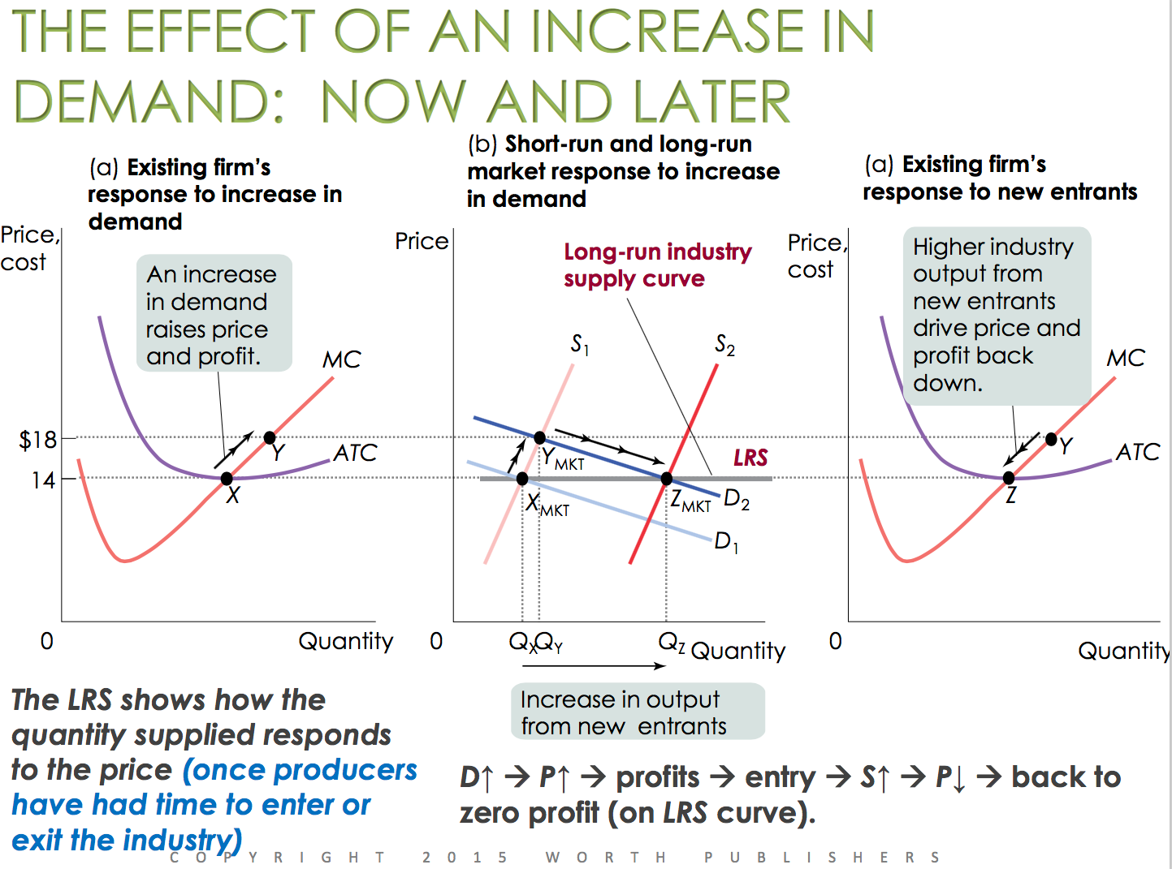

Once again, if the market price is above the break-even level, the firm can earn more in this industry than it could elsewhere. The long-run market equilibrium in a perfectly competitive industry with identical firms results in all firms:

1. Earning zero economic profit
2. Producing the quantity associated with their break-even price
3. Producing the profit-maximising quantity at which MR = MC

Monopoly

A monopolist is a firm that is the only producer of a good with no close substitutes; an industry controlled by a monopolist is known as a monopoly. Market power, within the scope of a monopoly, is substantially the ability of a firm to raise its prices.

But what does a monopolist do, exactly? A monopolist reduces the quantity supplied to QM and moves up the demand curve from C to M, raising the price to PM.

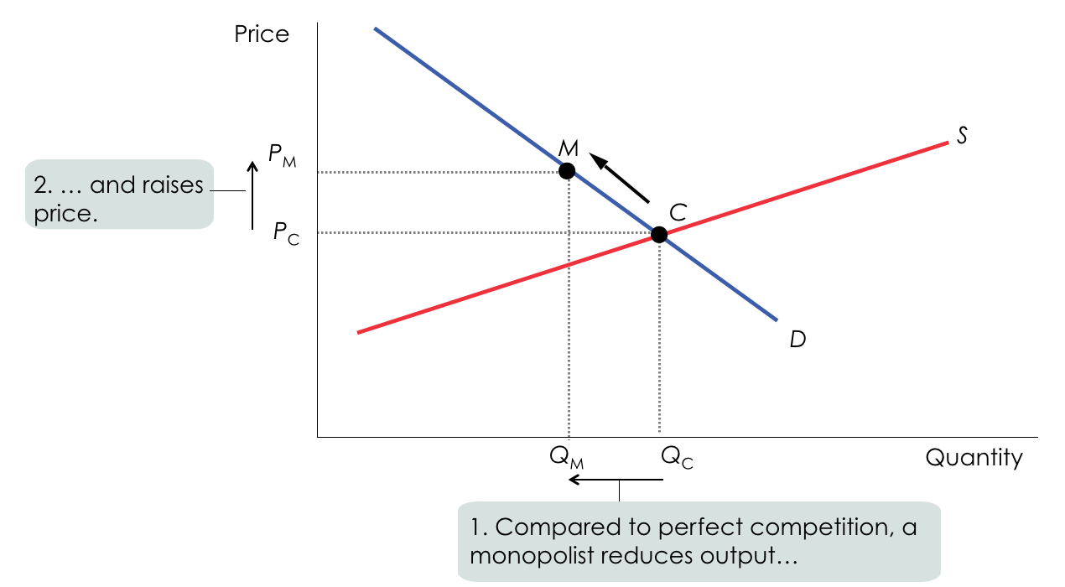

How do monopolists get away with this and protect their profit from new firms? If we think about it, profits will not persist in the long run unless there is a barrier to entry. Barriers to entry are quintessential in generating profit for the monopolist in the short/long run, and can take the form of:

1. CONTROL OF SCARCE NATURAL RESOURCES/INPUTS

E.g.: for many years, De Beers was a monopolist in the production of diamonds. The discovery of new diamonds mines in Russia and Australia caused a reduction of market power of De Beers.

1. INCREASING RETURNS TO SCALE

Firms tend to grow larger due to the fall of average total cost as output increases. In this case of barriers to entry, larger companies are more profitable and drive out smaller ones. A monopoly created and sustained by increasing returns to scale is called a natural monopoly (e.g.: Hoover Dam). With a natural monopoly, average total cost falls beyond the relevant output range.

The source of this condition is large fixed costs: when large fixed cost are required to operate, a given quantity of output is produced at lower average total cost by one large firm than by two or more smaller firms.

In short, a given quantity of output is produced more cheaply by one large firm than by two or more smaller firms.

1. TECHNOLOGICAL SUPERIORITY

A firm that maintains a consistent technological advantage over potential competitors can establish itself as a monopolist.

1. GOVERNMENT-MADE BARRIERS (PATENTS AND COPYRIGHTS)

A patent gives an inventor a temporary monopoly in the use or sale of an invention, while a copyright gives the creator of a literary or artistic work sole rights to profit from that work.

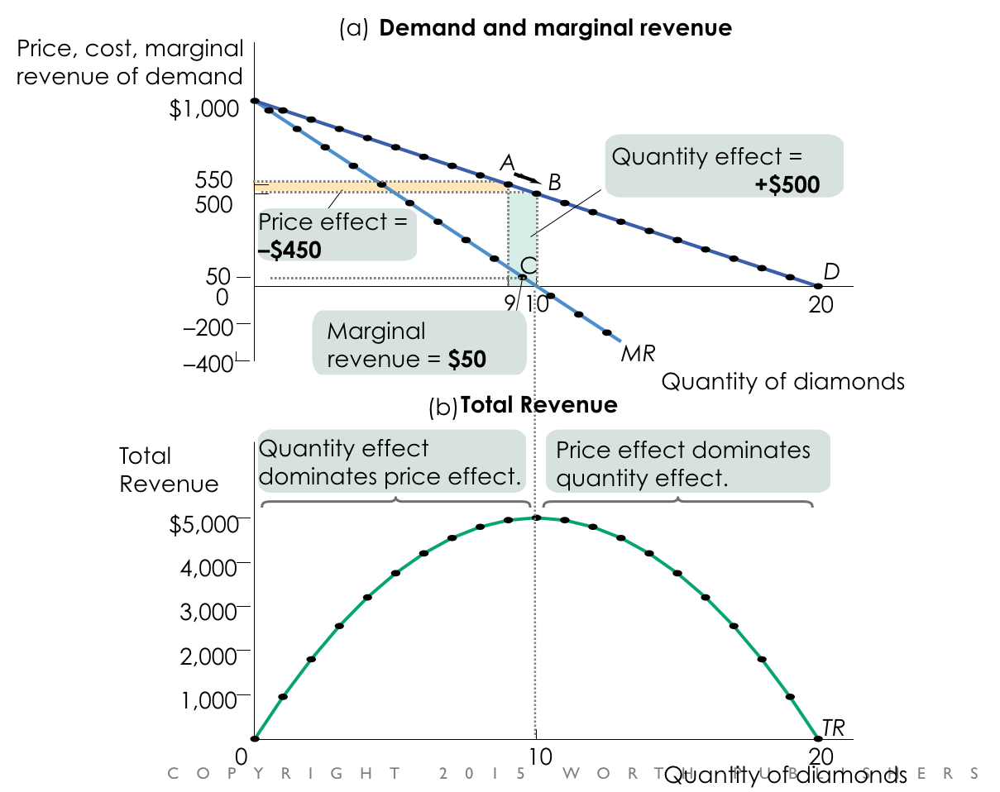

But a pressing question remains: how does a monopolist maximise their profit? The answer lies in the key difference between competitive firms and monopolists: while competitive firms cannot choose price, monopolists can.

All firms face the same rule: Profit is maximised at the Q where MR = MC. So MR is:

MR = ∆TR/ ∆Q.

The Demand curve, on the other hand:

P = a - bQ

TR = P(Q) \* Q = aQ - bQ^2

MR = a - 2bQ

So we are met with the same vertical intercept of the demand curve, but graced with a double slope.

An increase in production by a monopolist has two opposing effects on revenue:

1. A QUANTITY EFFECT

One more unit is sold, increasing total revenue by the price at which the unit is sold.

1. A PRICE EFFECT

To sell the last unit, the monopolist must cut the market price on all units sold. This decreases total revenue.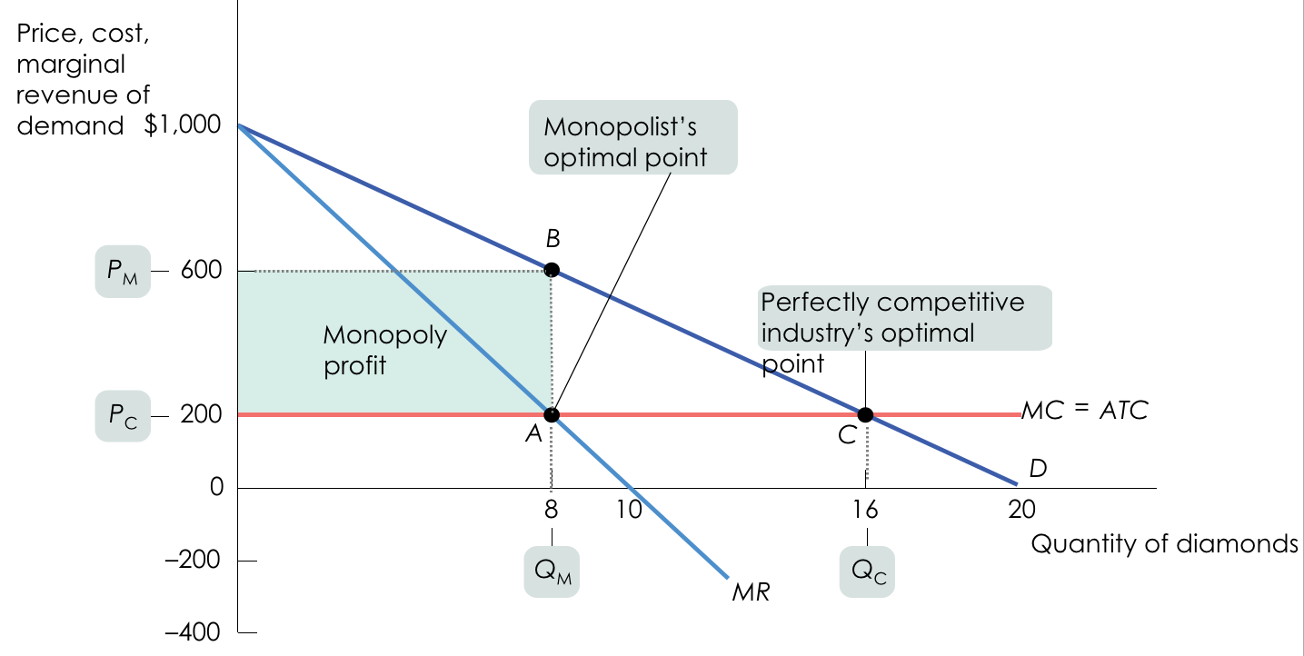

Within a monopoly, profit maximisation consist of two important steps:

1. CHOOSING A QUANTITY

Q (quantity) should be chosen where MR = MC. Once you’ve picked your quantity, follow the graph to the demand curve, which shows you how much consumers will pay.

1. CHOOSING A PRICE

You must choose the highest price you can get away with, which is the highest price consumers will pay for that quantity. In order to find the profit-maximising quantity of output for a monopolist, you look for the point where the MR curve crosses the MC curve.

But this isn’t the price the monopolist will choose. The firm will want to charge as much as it can. Why stop at MR if it can charge up to what the demand curve says people will pay?

As long as the monopoly has strong barriers to entry, profit will stay: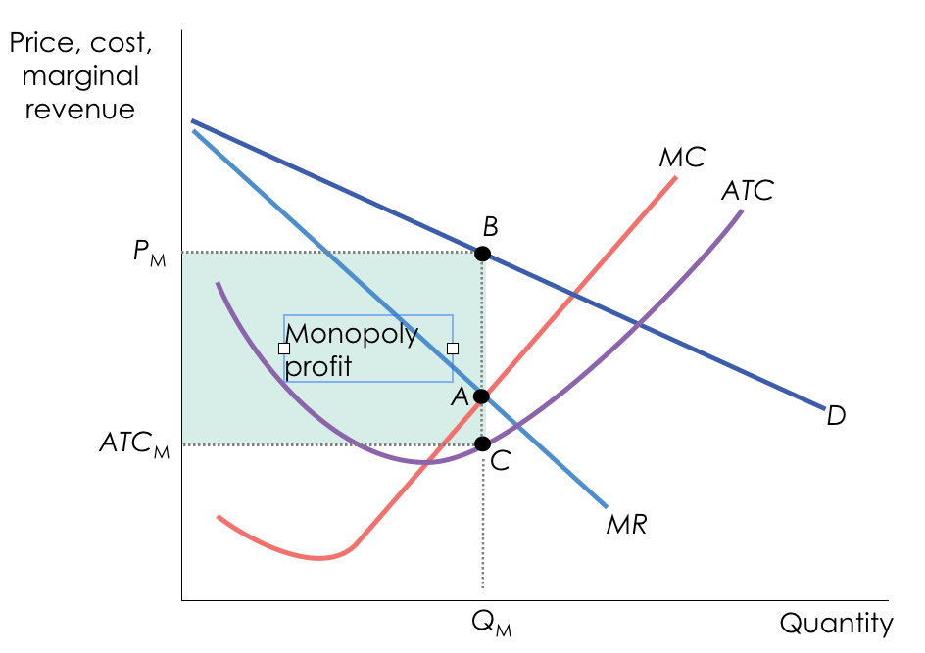

But is there a monopoly supply curve? Monopolists typically don’t have supply curves, as they control priced and there is no set relationship between P (price) and Q (quantity). supplied.

Monopoly also causes inefficiency: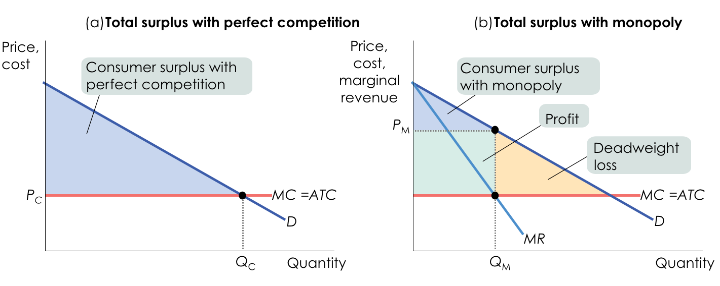

Monopoly profit naturally comes at consumers’ expense; when a monopoly raises prices and lowers Q, consumer surplus falls and deadweight loss is created. It is to avoid deadweight loss that government policy attempts (known as antitrust policy) to prevent monopoly behaviour.

What about natural monopolies?

Natural monopolies tend to bring lower costs, but there’s no guarantee the firm will voluntarily pass along its cost savings to consumers. Public policy can take two steps with regard to natural monopolies:

1. PUBLIC OWNERSHIP

Publicly owned companies, however, are often poorly run.

1. PRICE REGULATION

A price ceiling imposed on a monopolist does not create shortages if it is not set too low. If a monopoly’s price is regulated, consumer surplus rises and prices fall.

Within the realm of monopolies, we can also talk about price discrimination. While some firms are single-price monopolists (they offer their product to all consumers at the same price), others practice price discrimination (they charge different prices to different consumers for the same good). Although price discrimination might have a negative connotation, it increases sales and profits at a significant rate: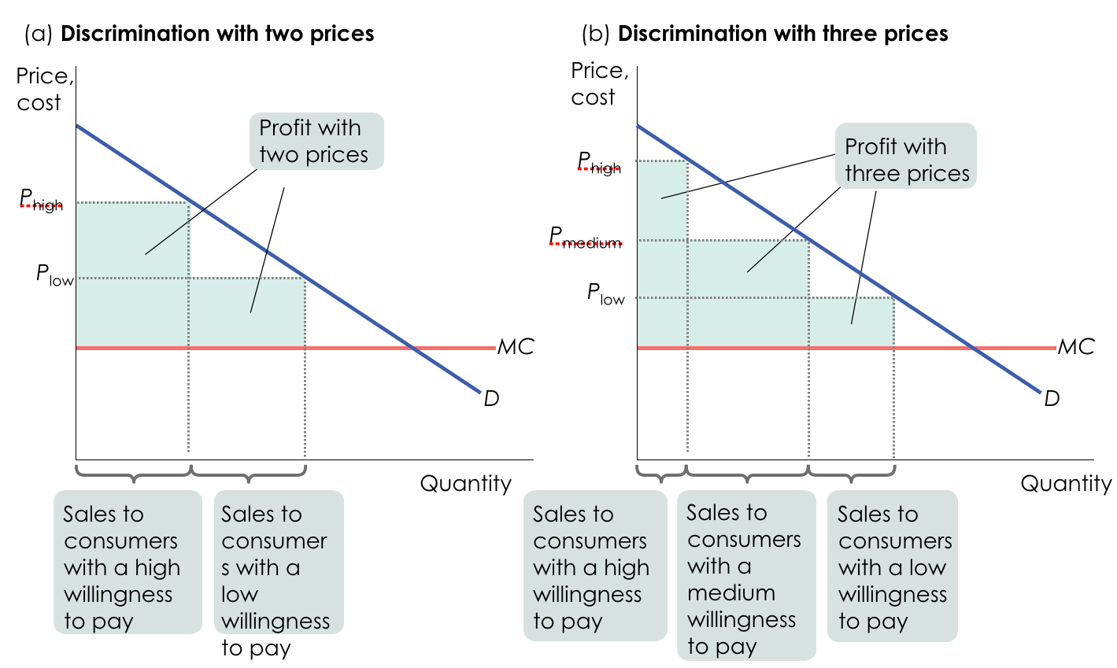

When perfect price discrimination can be employed, a firm will charge each customer a different price (the maximum price each is willing to pay). Under perfect price discrimination, the firm captures all consumer surplus as profit.

With price discrimination, there is no deadweight loss, because all mutual transactions are exploited. There is zero consumer surplus, as the entire surplus is captured by the monopolist in the form of profit.

Common techniques for price discrimination are:

1. ADVANCE PURCHASE RESTRICTIONS
2. VOLUME DISCOUNTS
3. TWO-PART TARIFFS

Oligopoly

An oligopoly is a market that is dominated by a small number of firms (e.g.: Apple, HTCA, Samsung, etc.). It isn’t necessarily made up of large firms; what matters is not the size, but how many competitors there are. When a small town has only two grocery stores, they may behave as oligopolists. In the case of large firms, the most important source of oligopoly is the existence of increasing returns to scale, which give bigger producers a cost advantage over smaller ones.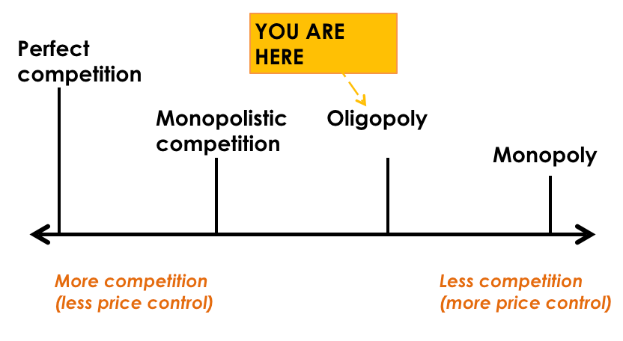

To get a better picture of market structure, economists often use the Herfindahl–Hirschman Index, or HHI. The HHI for an industry is the sum of the squares of each firm’s share of market sales.

For example, if there are three firms with 60%, 25%, and 15% market share each:

HHI = 60^2 + 25^2 + 15^2 = 4,450

According to Justice Department guidelines:

1. An HHI of less than 1,000 indicates a strongly competitive market
2. An HHI of 1,000 to 1,800 indicates a somewhat competitive market
3. An HHI above 1,800 indicates an oligopoly

If an HHI is above 1,000, a merger that results in a significant increase in the HHI will receive special scrutiny and is likely to be disallowed.

Studying oligopoly behaviour is complicated because it’s not a single firm considering its costs and pricing in a vacuum (like perfectly competitive firms and monopolies). The profits of a firm depend heavily on the actions taken by other firms.

Some of the key issues can be understood by looking at the simplest case: duopoly, which is an oligopoly consisting of only two firms. With only two firms in the industry, each realises that profits would be higher if it limited its production (and kept prices higher).

Collusion happens when firms cooperate in order to raise each other’s profits. The strongest form of collusion is a cartel, an agreement by several producers to restrict output in order to increase their joint profits. With oligopolies, however, we can also have what is called noncooperative behaviour (firms ignoring the effects of their actions on each others’ profits).

To maximise profit, how should firms behave?

It depends. Oligopolists frequently engage with the Game Theory, which is the study of behaviour in situations of interdependence; a way of predicting outcomes in strategic situations like oligopolies. It deals with any situation is which the reward to any one player — the payoff — depends not only on her own actions but also on those of other players in the game. In the case of oligopolistic firms, the payoff is simply the firm’s profit.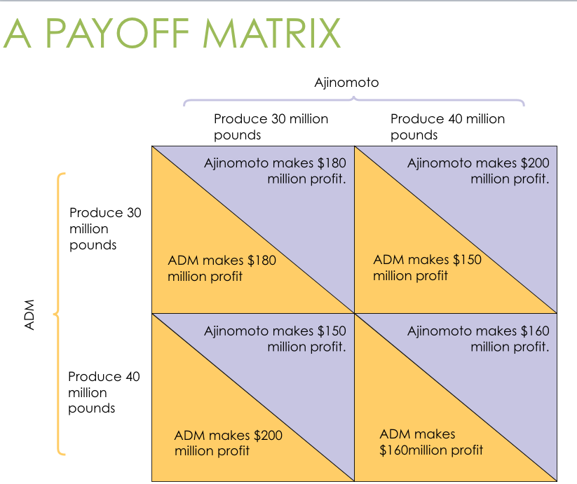

When each firm has an incentive to cheat but both are worse off if both cheat, the situation is known as the prisoner’s dilemma. The game is based on two premises:

1. Each player has an incentive to choose an action that benefits itself at the other player’s expense
2. When both players act in this way, both are worse off than if they had acted cooperatively

The original illustration of the prisoners’ dilemma occurred in a fictional story about two accomplices in crime, who have been caught by the police:

The police have enough evidence to put them behind bars for 5 years. They also know that the pair have committed a more serious crime, one that carries a 20-years sentence. The police put them in separate cells and say the following to each: “Here’s the deal: if neither you confess, you know that we will send you to jail for 5 years. If you confess and implicate your partner, and she does not do the same, we will reduce your sentence from 5 to 2. But, if your partner confesses and you don’t, you will get the maximum 20 years. And if both of you confess, we will give you both 15 years”.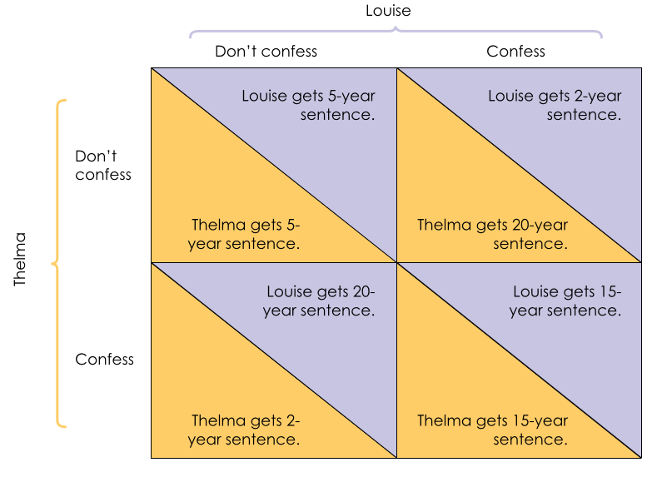

Within the realm of game theory, a dominant strategy is a strategy that is a player’s best action regardless of the action taken by the other player. Depending on the payoffs, a player may or may not have a dominant strategy.

A Nash equilibrium (also known as noncooperative equilibrium), on the other hand, is the result when each player in a game chooses the action that maximises his or her payoff given the actions of other players, ignoring the effects of his or her action on the payoffs received by those other players.

How can the prisoners’ dilemma be overcome?

If a game is played repeatedly, players may engage in strategic behaviour, sacrificing short-run profit to influence future behaviour. A tit for tat, in this case, is a strategy of playing cooperatively at first, then doing whatever the other player did in the previous period.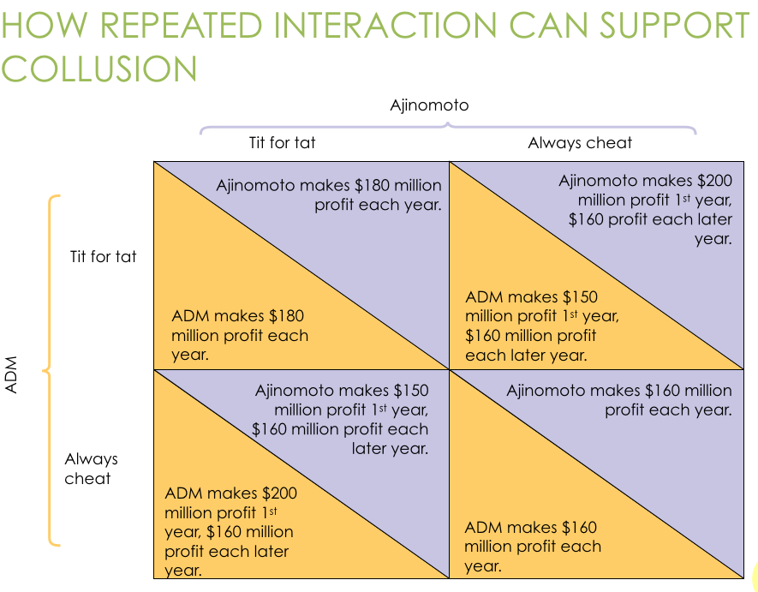

The prisoner’s dilemma can actually be overcome. As seen in the dilemma, when oligopolists expect to compete with one another over an extended period of time, each individual firm will conclude that it is in its own best interest to be helpful to the other firms in the industry. Thus, each firm will restrict its output is a way that raises the profits of the other firms, expecting them to return the favour. In this case, firms engage in what we call tacit collusion.

In practice, oligopolies operate under legal restrictions in the form of antitrust policies, which are efforts undertaken by the government to prevent oligopolistic industries from becoming or behaving like monopolies.

HOW DO ANTITRUSTS WORK?

Let’s explain this with an example. Railroads created the first national markets for many goods in the later 1800’s, leading to larger firms and cartels. Rockefeller’s lawyers solved the cartel cheating problem by creating “trusts” controlled by a single board of trustees. The public backlash created the first “antitrust” law: The Sherman Act of 1890.

Many, however, succeeded in achieving tacit collusion.

TACIT COLLUSION

Tacit collusion, however, is limited by a number of factors, such as:

* Less concentration
* Complex products and pricing scheme
* Differences in interests
* Bargaining power of buyers

But when collusion breaks down and prices collapse, there is a price war. To limit competition, oligopolists often engage in product differentiation, an attempt by a firm to convince buyers that its product is different from the products of other firms in the industry. Oligopolists often avoid competing directly on price, engaging in nonprice competition through advertising and other means instead.

In price leadership, one firm sets its price first, and other firms then follow. Cartels may be tough to keep together, but oligopoly can still maintain prices (and profits) that are higher than those of competitive firms.

The Big Picture

MICROECONOMICS VS MACROECONOMICS

What is microeconomics? Microeconomics is concerned with the consumption and production decisions of individual consumers and producers and with the allocation of scarce resources among industries. At the time of the Great Depression in 1929, microeconomics was already quite well-developed, while macroeconomics was not.

An effort to understand economic slumps and find ways to prevent them, on the other hand, is at the core of macroeconomics, such as what caused the Great Depression.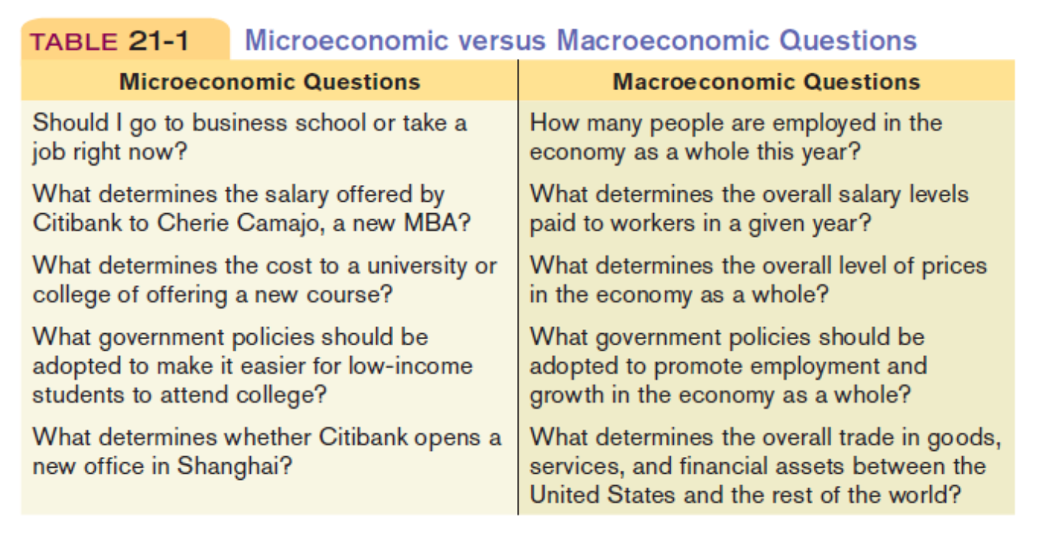

THE ORIGINS OF MACROECONOMICS

The Great Depression started in the United States after a major fall in stock prices that became worldwide news with the stock market crash of October 29, 1929 (known as Black Tuesday).

Between 1929 and 1932, worldwide gross domestic product (GDP) fell by an estimated 15%. Some economies started to recover by the mid-1930s. However, in many countries, the negative effects of the Great Depression lasted until the beginning of World War II.

International trade plunged by more than 50%. Unemployment in the U.S. rose to 25% and in some countries rose as high as 33%.

MACROECONOMICS AFTER THE GREAT DEPRESSION

Over time, macroeconomics has broadened its objectives, such as long-run economic growth, inflation, and open-economy macroeconomics.

PRE-1930’S CONVENTIONAL WISDOM

Problems such as unemployment are resolved without government intervention through the working of the invisible hand (AKA, thanks to the existence of the self-regulating market described by Adam Smith).

POST-1930’S CONVENTIONAL WISDOM

It was concluded, thanks to Keynesian economics, that economic slumps are caused by inadequate spending, and they can be mitigated by government intervention.

THE BUSINESS CYCLE

In 1936, the British economist John Maynard Keynes published “The General Theory of Employment, Interest, and Money”, a book that transformed macroeconomics. Since the 1930’s, the U.S. (and most national governments) have used tools such as these to improve the economy:

1. FISCAL POLICIES

Use changes in government spending and taxes to affect overall spending

1. MONETARY POLICIES

Use changes in the quantity of money to alter interest rates and affect overall spending.

In general, we can say that Keynes established the idea that managing the economy is a governmental responsibility. Keneysian ideas continue to have a strong influence on both economic theory and public policy. In 2008-2009, Congress, the White House, and the Federal Reserve took steps to fend off an economic slump.

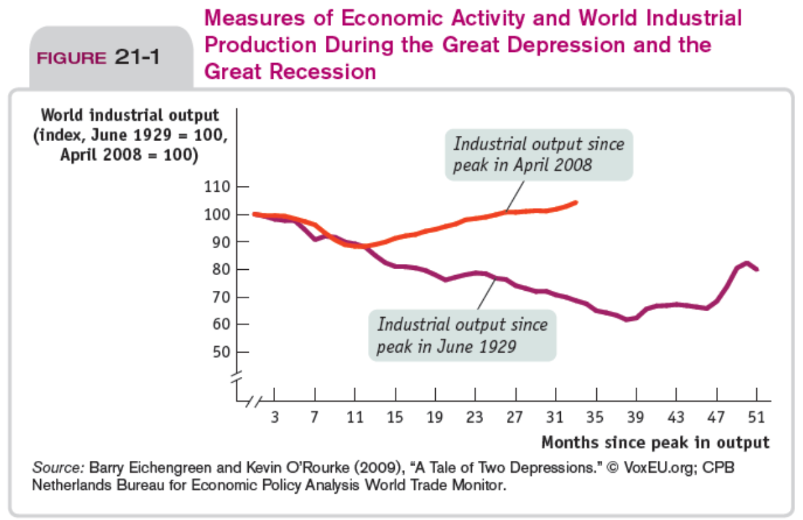

Why this difference?

Policymakers responded quite differently in both instances:

1. During the Great Depression: some countries’ monetary authorities raised interest rates, Government cut spending and raised taxes
2. In the aftermath of the 2008 crisis interest rates were slashed, many countries increased spending and reduced taxes

In order to chart these fluctuations, there are three elements that should be considered:

1. BUSINESS CYCLE

The short-run alternation between recessions and expansions.

1. RECESSIONS (CONTRACTIONS)

Periods of economic downturn, when output and employment are falling.

1. EXPANSIONS (RECOVERIES)

Periods of economic upturn, when output and employment are rising.

The point at which the economy turns from expansion to recession is a business-cycle peak, while the point at which the economy turns from recession to expansion is a business-cycle trough. With regards to recession, its most important effect is on the ability of workers to find and hold jobs.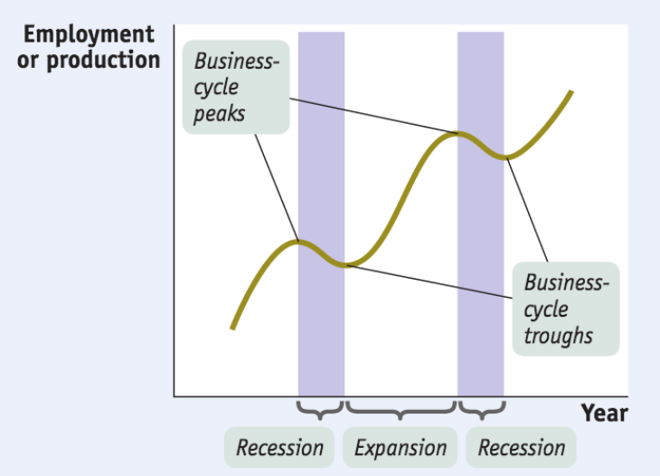

TAMING THE BUSINESS CYCLE

The business cycle is a main concern of modern policy makers: they try to smooth out the business cycle.

INFLATION AND DEFLATION

A rising overall level of prices is called inflation, while an overall falling level of prices is deflation. The economy has price stability when the overall level of prices changes slowly or not at all.

In the short run, movements in inflation are closely related to the business cycle. When the economy is depressed and jobs are hard to find, inflation tends to fall; when the economy is booming, inflation tends to rise.

In the long run, the overall level of prices is mainly determined by changes in the money supply.

Both inflation and deflation, however, are problematic. Inflation discour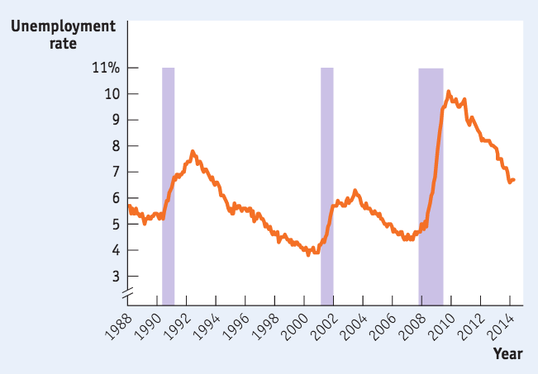ages people from holding onto cash (because cash loses value if prices are rising). In extreme cases, people stop using cash altogether. Deflation, on the other hand, can cause the reverse problem. Since cash gains value if the price level is falling, holding on to it is more attractive than investing in new factories and other productive assets. This can deepen a recession.

INTERNATIONAL IMBALANCES

What is the difference between a trade deficit and a trade surplus?

A trade deficit is when the value of goods and services bought from foreigners is more than the value of goods and services sold to them.

A trade surplus, on the other hand, is when the value of goods and services bought from foreigners is less than the value of the goods and services sold to them.

GDP and the CPI

How can we compare the sizes of two economies when they produce different things? By comparing the value of their production. GDP (gross domestic product) is the most important and common way to estimate an economy’s size.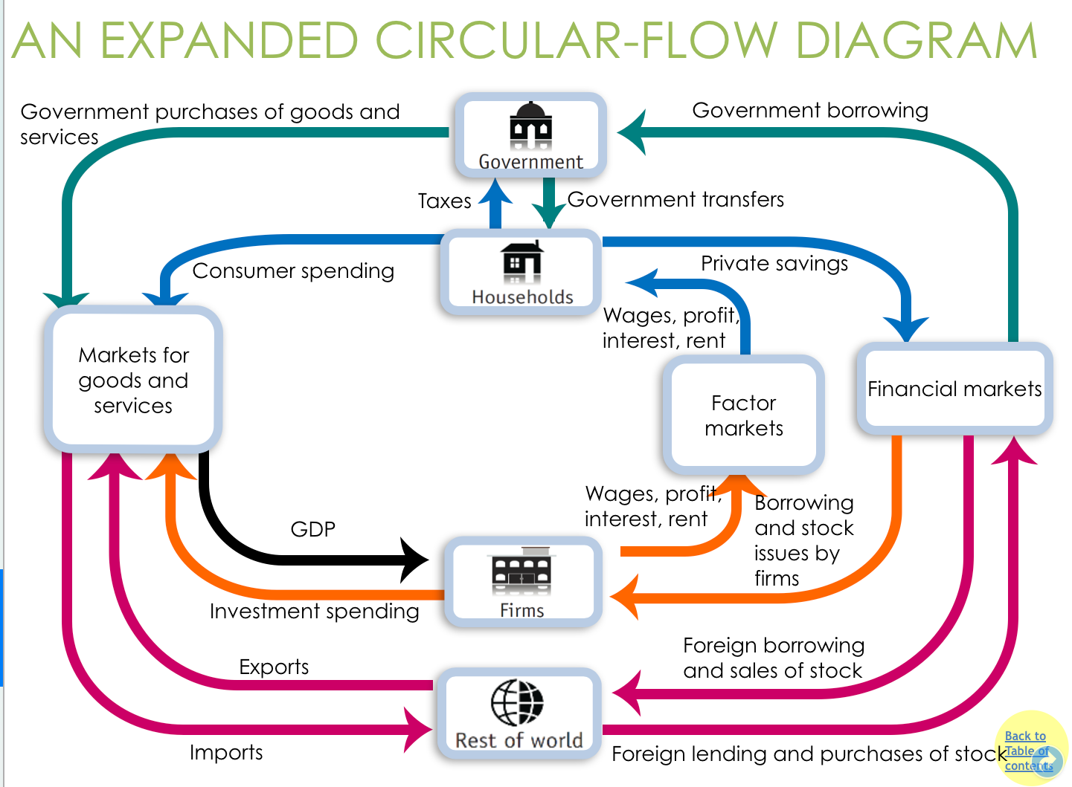

With NIPA (the national income and product accounts), we can measure nations’ economic performance and track the economy’s condition throughout the business cycle.

There are several key concepts behind NIPA:

1. CONSUMER SPENDING

Household spending on goods and services.

1. STOCK

A share in the ownership of a company held by a shareholder.

1. BOND

A debt security, under which the issuer owes the holders a debt and, depending on the terms of the bond, is obliged to pay them interest and/or to repay the principal at a later date.

1. GOVERNMENT TRANSFER

Payment by the government to individuals for which no good or service is provided in return.

1. DISPOSABLE INCOME

Income plus government transfers minus taxes; available to spend on consumption and to save.

What’s also important to remember with NIPA is that households don’t spend all of their disposable income. Some of it is saved in the financial markets:

1. PRIVATE SAVINGS

Disposable income minus consumer spending.

1. FINANCIAL MARKETS

The banking, stock, and bond markets, which channel private savings and foreign lending into investment spending, government borrowing, and foreign borrowing.

The government spends and borrows for various reasons:

1. GOVERNMENT BORROWING

The total amount of funds borrowed by federal, state, and local governments in the financial markets.

1. GOVERNMENT PURCHASES OF GOODS AND SERVICES

Total expenditures on goods and services by federal, state, and local governments.

There are two types of movements within NIPAs:

1. EXPORTS

Goods and services sold to other countries.

1. IMPORTS

Goods and services purchased from other countries.

GDP

GDP (Gross Domestic Product) is the market value of all final goods and services produced within a country in a year. GDP can be calculated in three ways:

1. Add up the total value of all final goods and services produced

The value added of a producer is the value of its sales minus the value of its purchases of intermediate goods and services. In this method, final goods and services are goods and services sold to the final, or end, user, while intermediate goods and services are goods and services (bought from one firm by another firm) that are inputs for production of final goods and services.

1. Add up all spending on domestically produced final goods and services

This results in the equation:

GDP = C + I + G + X - IM

Where:

* C = consumer spending
* I = investment spending
* G = government purchases of goods and services
* X = sales to foreigners
* IM = imports

1. Add up the total factor income earned by households from firms in the economy

This includes:

* Wages earned by labour
* The rent earned by those who lease their land/structures to firms
* Dividends (profits paid to the shareholders, the owners of the firms’ physical capital)

What’s curious about GDP is that it doesn’t matter how we measure the production, since one person’s spending is another’s income. The sale of used goods and the sale of financial assets (such as stocks and bonds) are not included.

Only production that takes place within the borders of a country is included in GDP (e.g.: cars produced in Mexico by American firms are not included in the U.S. GDP). GDP is like an annual income, as it measures production during a given period.

The problem with GDP, however, is that it does not count the value of services family members provide to each other, save for the estimated value of housing “services” for those that own their home (instead of renting).

THE TWO TYPES OF GDP

We need to be able to track the quantity of total output over time through two types of GDP:

1. REAL GDP

The total value of the final goods and services produced in the economy during a given year, calculated using the prices of a selected base year.

1. NOMINAL GDP

The value of all final goods and services produced in the economy during a given year, calculated using the prices current in the year in which the output is produced.

Except in the base year, real GDP is not the same as nominal GDP (output valued at current prices). Chained dollars is the method of calculating changes in real GDP using the average between the growth rate calculated on an early base year and the growth rate calculated on a late base year. GDP per capita, on the other hand, is the average GDP per person and is not by itself an appropriate policy goal.

THE ORIGINS OF NATIONAL ACCOUNTS

The national accounts owe their creation to the Great Depression. The only data available were scattered statistics (railroad data, etc.). Simon Kuznets (a young Russian-born economist) developed a set of national income accounts. The first version was presented to Congress in 1937.

The push to complete the national accounts came during World War II, when policy makers were in even more need of comprehensive measures of the economy’s performance. The federal government began issuing estimates of gross domestic product and gross national product in 1942.

GDP OR HDI?

The human development index (HDI) emphasises that outcomes for people and their capabilities should be the ultimate criteria for assessing the progress of a country, not economic growth alone. It accounts for average achievements in:

1. LIFE EXPECTANCY (proxy for leading a long and healthy life)
2. EDUCATION (proxy for being knowledgeable)
3. INCOME PER CAPITA (proxy for command over resources to have a decent standard of living)

HDI can be defined as the expansion of people’s freedoms to live long, healthy and creative lives; to advance other goals they have reason to value; and to engage actively in shaping development equitably and sustainably on a shared planet.

AGGREGATE PRICE LEVEL

An aggregate price level is a measure of the overall level of prices in the economy. To measure the aggregate price level, economists calculate the cost of purchasing a market basket, which is a hypothetical set of consumer purchases of goods and services.

PRICE INDEX

A price index is the cost of purchasing a given market basket in a given year, where that cost is nor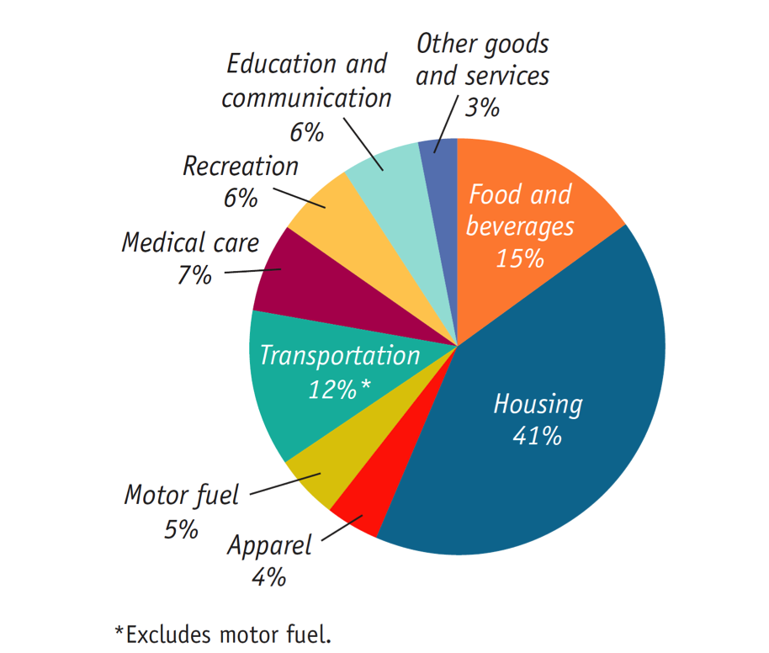malised so that it is equal to 100 in the selected base year. A price index in a given year can be calculated as:

(cost of market basket in a given year)/(cost of market basket in base year) x 100

INFLATION RATE, CPI, AND OTHER INDEXES

Inflation rate is the yearly percentage change in a price index, typically based upon consumer price index, or CPI, the most common measure of the aggregate price level. It can be calculated as:

Inflation rate = (Price index in year 2 - price index in year 1)/(price index in year 1) x 100

The consumer price index, or CPI, measures the cost of the market basket of a typical urban family. E.g.:

There are several other price measures we can talk about:

1. PRODUCER PRICE INDEX (PPI)

It’s similar to the CPI but measures changes in the prices of goods purchased by producers.

1. GDP DEFLATOR

Economists also use the GDP deflator, which measures the price level by calculating the ratio of nominal to real GDP. The GDP deflator for a given year is 100 times the ratio of nominal GDP to real GDP in that year.

INFLATION AND DEFLATION

Inflation does not make everyone poorer because incomes often rise with prices. A better measure would be:

1. REAL WAGE

This is the wage rate divided by the price level.

1. REAL INCOME

This is income divided by the price level.

The rate of change does matter, and thus it’s crucial to distinguish between the level of prices and the inflation rate. The inflation rate can be calculated as:

(Price level in year 2 - Price level in year 1)/(Price level in year 1) x 100

What does high inflation cost, though? Shoe-leather costs are crucial to distinguish between the level of prices and the inflation rate; since cash loses its value quickly during high inflation, people waste more time running around to spend it as fast as they can. Menu costs are the real cost of changing a listed price.

When inflation is high, merchants may decide to stop listing prices in local currency and may use a more stable currency, such as the U.S. dollar (e.g.: within the real estate market in Israel in the mid-1980’s, prices were quoted in US dollars, even though payments were made in Israeli shekels).

Unit-of-account costs are costs arising from the way inflation makes money a less reliable unit of measurement. Calculations are hard to make when inflation is high. The effect is to reduce the quality of economic decisions: the economy as a whole makes less efficient use of its resources because of the uncertainty caused by changes in the unit of account.

Unit-of-account costs may be particularly important in the tax system because inflation can distort the measures of income on which taxes are collected.

WINNERS AND LOSERS FROM INFLATION

If inflation is different from predictions, some will lose and some will benefit. The main reason inflation sometimes helps some people while hurting others is that economic transactions often involve contracts that extend over a period of time, such as loans, and these contracts are normally specified in nominal terms.

In case of a loan, the borrower receives a certain amount of funds at the beginning, and the loan contract specifies the interest rate on the loan and when it must be paid off. The interest rate is the return a lender receives for allowing borrowers the use of their savings for one year, calculated as a percentage of the amount borrowed.

There are two types of interest rates involved:

1. NOMINAL INTEREST RATE

The interest rate expressed in dollar terms.

1. REAL INTEREST RATE

The nominal interest rate minus the rate of inflation.

When a borrower and a lender enter into a loan contract, the contract is normally written in dollar terms (the interest rate is nominal). Each party to a loan contract has an expectation about the future rate of inflation and therefore an expectation about the real interest rate on the loan.

If the actual inflation rate is higher than expected, borrowers gain at the expense of lenders: borrowers will repay their loans with funds that have a lower real value than had been expected. Conversely, if the inflation rate is lower than expected, lenders will gain at the expense of borrowers: borrowers must repay their loans with funds that have a higher real value than had been expected.

DEFLATION

When the overall price level decreases so that inflation rate becomes negative, it is called deflation. It is the opposite of the often-encountered inflation. A reduction in money supply or credit availability is the reason for deflation in most cases.

WINNERS AND LOSERS FROM DEFLATION

Unexpected deflation creates winners and losers. Between 1929-1933 (Great Depression) the CPI fell by 35%. This meant that debtors, including many farmers and homeowners, saw a sharp rise in the real value of their debts, which led to bankruptcy and helped create a banking crisis, as lenders found their customers unable to pay back their loans.

INFLATION IS EASY, DISINFLATION IS HARD

The policies needed to slow prices usually cause unemployment. Disinflation is the process of bringing the inflation rate down.

Unemployment

We can define unemployment through two main elements:

1. EMPLOYMENT RATE

The percent of the total number of people in the labor force who have a job.

1. UNEMPLOYMENT RATE

The percent of the total number of people in the labor force who are unemployed. The U.S. Census Bureau considers the unemployed those who are: “jobless, looking for jobs, and available for work”. Here, retired individuals don’t count. An individual is considered unemployed if he or she does not currently have a job and has been actively seeking a job during the past four weeks.

It can be calculated as:

(Unemployed)/(Labor force) x 100

The unemployment rate is a good indicator of how easy or difficult it is to find a job given the current state of the economy. It can, however, overstate the true level of unemployment, because even if the labor market is healthy, it takes time to find the right job. It can also understate the true level of unemployment, because you are not “unemployed” if you have given up looking for a job because there are no jobs available.

1. LABOR FORCE

All workers, employed or unemployed.

1. LABOR FORCE PARTICIPATION RATE

The percentage of adults (16 and over) in the labor force. It can be calculated as:

(Labor force)/(Adult population) x 100

PROBLEMS WITH UNEMPLOYMENT STATISTICS

There are several issues associated with unemployment statistics:

1. DISCOURAGED WORKERS

Nonworking people who have given up looking for work for the time being. Not considered unemployed.

1. MARGINALLY ATTACHED WORKERS

Those who were available and actively looked for work recently but are not currently looking (in the past 12 months but not in the past 4 weeks).

1. UNDEREMPLOYED WORKERS

People who work part time because they cannot find full-time jobs.

THE PERFECT DEFINITION OF UNEMPLOYMENT

Economists also look at indicators other than the unemployment rate to measure the quality of jobs or how well people are matched to their jobs:

1. LABOR FORCE PARTICIPATION RATE
2. NUMBER OF FULL-TIME 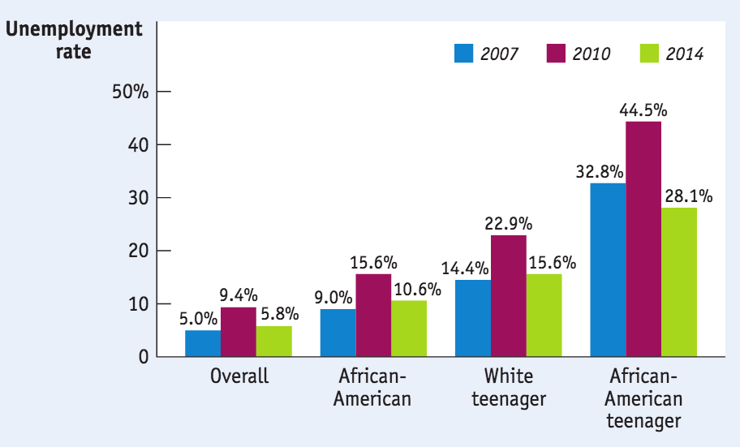JOBS
3. AVERAGE WAGES

Unemployment rates also vary greatly between groups:

Unemployment rates could still be rising even when real GDP growth rate is positive, which is a period called jobless recovery. Some unemployment, on the other hand, is natural.

There are three main types of unemployment:

1. FRICTIONAL

Frictional unemployment is a type of unemployment that arises when workers are searching for new jobs or are transitioning from one job to another.

1. STRUCTURAL

Structural unemployment refers to a mismatch between the jobs available and the skill levels of the unemployed. Unlike cyclical unemployment, it's caused by forces other than the business cycle. ﻿﻿It occurs when an underlying shift in the economy makes it difficult for some people to find jobs, and some causes can be:

* Labor unions
* Efficiency wages (wages that employers set above the equilibrium rate as an incentive for better employee performance)
* Side effects of government policies
* Mismatches between employees and employers

In structural unemployments, unions (an association of workers that ba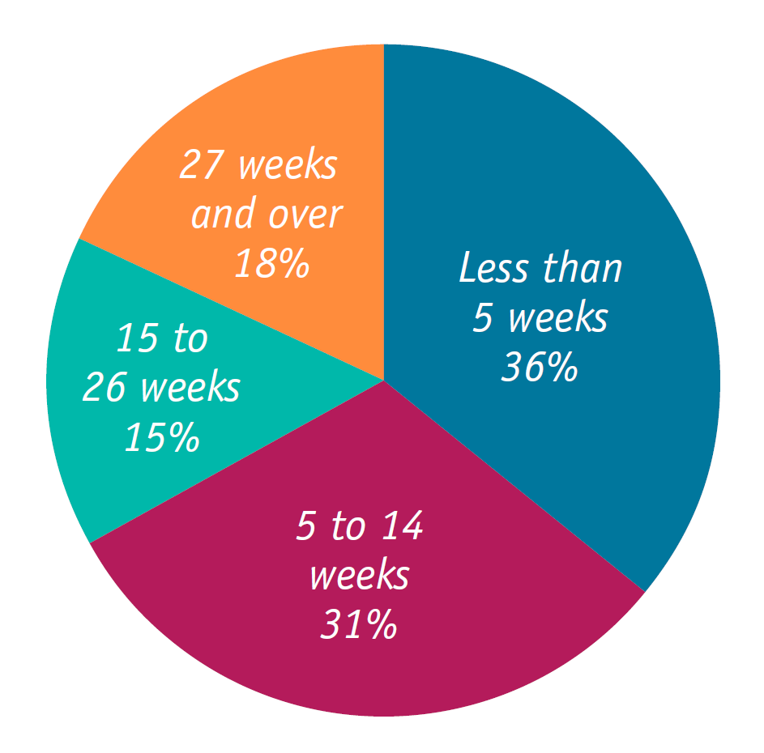rgains collectively with employers over wages, benefits, and working conditions) might act to increase wages by restricting entry into a profession with licensing requirements.

1. CYCLICAL

Cyclical unemployment is the component of overall unemployment that results directly from cycles of economic upturn and downturn. Unemployment typically rises during recessions and declines during economic expansions.

In a healthy year, many workers move into and out of employment/unemployment each month. The short duration of unemployment for most workers suggests that most unemployment in 2007 was frictional:

Frictional and structural unemployment are always present; they are “natural”. Actual unemployment can be considered the union of natural unemployment and cyclical unemployment, which is correlated with the business cycle.

Lower growth is usually correlated with higher unemployment for two main reasons:

1. When GDP falls, firms lay off workers
2. Idle labor and capital lead to economic growth not being maximised, and thus a lowering in the ability of the economy to create more jobs

WHAT CAUSES CHANGES IN UNEMPLOYMENT

1. CHANGES IN CHARACTERISTICS OF THE LABOR FORCE (demographics)
2. CHANGES IN LABOR MARKET INSTITUTIONS (unions, new technology)
3. CHANGES IN GOVERNMENt POLICIES (job training programs)

Savings and Investments

Having a good idea isn’t enough to build a business; entrepreneurs need funds. You have to spend money to make money.

Two of the essential ingredients in economic growth are increases in the economy’s levels of human capital and physical capital. Human capital is provided by government through public education. Physical capital, with the exception of infrastructure, is mainly created through private investment spending — i.e. spending by firms rather than by the government.

But who pays for private investment spending?

In the modern economy, individuals and firms that create physical capital often do it with other people’s money – money that they borrow or raise by selling stock.

To understand how investment spending is financed, we need to look first at how savings and investment spending are related for the economy as a whole, then examine how savings are allocated among investment spending projects.

A savings-investment spending identity refers to the fact that savings and investment spending are always equal for the economy as a whole. Let’s recalled that GDP is equal to total spending on domestically produced final goods and services:

GDP = C + I + G

One person’s spending is another person’s income: the only way people can earn income is by selling something to someone else, and every dollar spent in the economy creates income for somebody. Total income can go to consumer spending (C) or government purchases of goods and service (G) or be saved (S):

GDP = C + G + S

So:

Total income = consumption spending + savings

We can compute the total spending as consisting of either consumption spending (C + G) or investment spending (I):

GDP = C + G + I

So:

Total income = consumption spending + investment spending

By putting these two equations together, we get:

C + G + S = C + G + I

And, by subtracting (C + G) from both sides

S = I

Or:

Savings = Investment Spending

Now let’s take a closer look at savings. Households are not the only parties that can save in an economy. Government can also save (or not). The relationship between tax revenue and government spending is complex, but we can refer to three crucial concepts in order to understand it:

1. BUDGET SURPLUS

Excess of tax revenue over government spending.

1. BUDGET DEFICIT

Excess of government spending over tax revenue.

1. BUDGET BALANCE

The difference between tax revenue and government spending.

Budget balance can be defined as:

SGovernment = T - TR - G

Where:

* T = the value of tax revenues
* TR = the value of government transfers

Budget balance is equivalent to savings by the government – if it’s positive the government is saving; if it’s negative the government is dissaving.

National savings, on the other hand, is equal to the sum of the budget balance and private savings. Private savings is disposable income (income after tax) minus consumption, and is given by:

SNational = SGovernment + SPrivate

And since S = I has been established, we can say that:

SNational = I (National Savings = Investment)

THE SAVINGS-INVESTMENT SPENDING IDENTITY IN AN OPEN ECONOMY

An open economy is an economy in which goods and money can flow into and out the country. But what happens when a country sends savings to or receives savings from abroad?

This affects the savings-investment spending identity because savings need not to be spent on investment spending projects in the same country in which the savings are generated.

Any given country can receive inflows of funds — foreign savings that finance investment spending in that country. Any given country can also generate outflows of funds – domestic savings that finance investment spending in another country.

We can define the total flows of funds in/out of a country as net capital inflow, which is:

Total Inflows - Total Outflows

Typically, a country with a positive net capital inflow has an extra flow of funds from abroad that can be used for investment spending. A country that spends more on imports than it earns from exports must borrow the difference from foreigners. Net capital inflow can be calculated as:

NCI = IM - X (imports - exports)

And we can thus rearrange GDP into:

I = (GDP - C - G) + (IM - X)

We know that GDP − C − G is equal to national savings, so:

I = SNational + (IM - X) = SNational + NCI

Or:

Investment spending = national savings + net capital inflow

Income and Expenditure

Since households and firms are mutually interdependent, booms and busts involve chain reactions. The multiplier helps us understand the extent of the chain reactions.

Basically, we want to understand how much extra income and spending are created from an initial change in spending (e.g.: if construction spending rises by $100 billion, how much does this affect the economy?).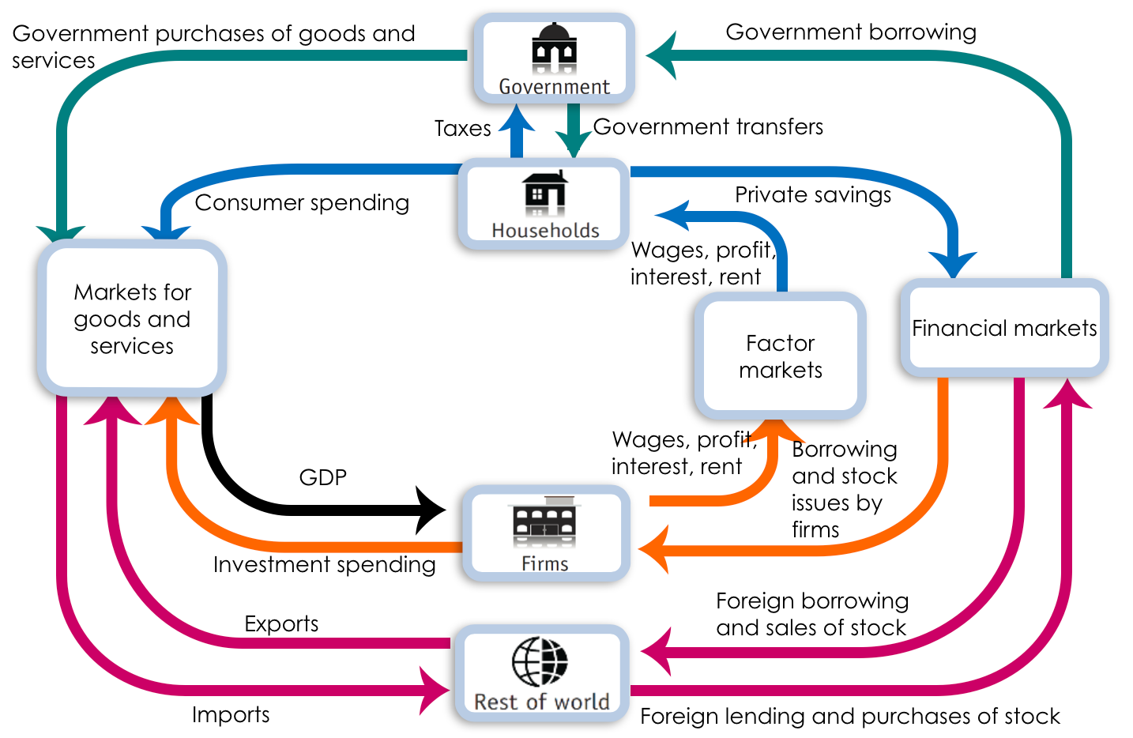

THE MARGINAL PROPENSITY TO CONSUME (MPC)

This notion can be dissected into four simple assumptions:

1. Producers are willing to supply additional output at a fixed price. As a result, changes in aggregate spending translate into changes in aggregate output, as measured by real GDP.
2. We take interest rate as given.
3. We assume that there is no government spending and no taxes.
4. We assume that exports and imports are zero.

Given these simplifying assumptions, consider what happens if there is a change in investment spending.

Suppose that home builders decide to spend an extra $100 billion on home construction over the next year. The direct effect of this increase in investment spending will be to increase income and the value of aggregate output by the same amount: each dollar spent on home construction translates into a dollar’s worth of income for construction workers, suppliers of building materials, electricians etc. If the process stopped here, the increase in housing investment spending would raise overall income by exactly $100 billion.

But the process does not stop there. The increase in aggregate output leads to an increase in disposable income that flows to households in the form of profits and wages. The increase in household’s disposable income leads to a rise in consumer spending, which, in turn, induces firms to increase output yet again. This means that there are multiple rounds of increases in aggregate output.

But how large is the total effect on aggregate output if we sum the effect from all these rounds of spending increases?

A lot depends on how much consumers spend when they receive more income. MPC can be calculated as:

MPC = (ΔConsumer spending)/(ΔDisposable income)

Whatever is not spent is saved, so the Marginal propensity to save (MPS) is the fraction of an additional dollar of disposable income that is saved:

MPS = 1 - MPC

THE MULTIPLIER EFFECT

Each $1 increase in aggregate spending raises both real GDP and disposable income by $1—and causes people to spend money. How much?

If investment spending rises by $100 billion, this will lead to a second-round increase of MPC × $100 billion. It is followed by a third-round increase in consumer spending of MPC × MPC × $100 billion, and so on up to:

Total increase in real GDP = (1 + MPC + MPC^2 + MPC^3 + …) x $100 billion

Or:

Total increase in real GDP from a $100 billion rise in I = (1)/(1 - MPC) x $100 billion

We have just actually described the effects of a change in investment spending, but the same analysis can be applied to any other change in aggregate spending. If ΔAAS signals an autonomous change in aggregate spending, and ΔY signals a change in real GDP, then;

ΔY = (1)/(1 - MPC) x ΔAAS

And thus, the multiplier is:

(ΔY)/(ΔAAS) = (1)/(1-MPC)

But why is the multiplier so important? We will use the concept of multiplier to analyse the effects of fiscal and monetary policies on consumer spending, investment spending, and the income-expenditure model.

THE EFFECTS OF FISCAL AND MONETARY POLICIES ON CONSUMER SPENDING

Households are constantly confronted w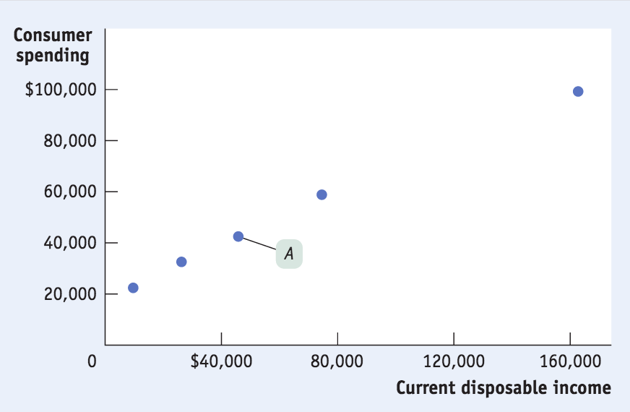ith choices — not just about what to consume but also about how much to spend. And that depends mostly on income.

Within consumer spending we have what we call current disposable income. This refers to the income retained after taxes are paid and government transfers are received. A consumption function, on the other hand, is an equation showing how an individual household’s consumer spending varies with the household’s disposable income:

C = a + MPC x yd

Where:

* c = a household’s consumer spending
* yd = household disposable income
* MPC = marginal propensity to consume
* a = a constant, autonomous consumer spending (what a family would spend even with zero income)

Within this equation, when yd goes up by $1, c goes up by MPC x $1.

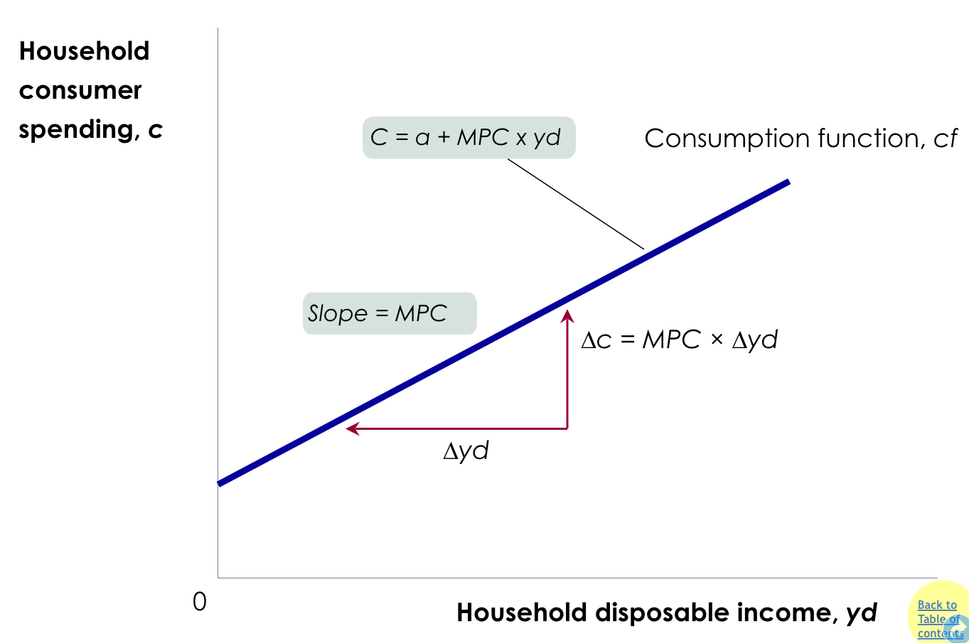

Another function we need to remember when considering the relationship between consumer spending and fiscal/monetary policies is the aggregate consumer function. This function represents the relationship for the economy as a whole between aggregate disposable income and aggregate consumer spending:

C = A + MPC x YD

Sometimes, this function shifts due to factors such as changes in expected future disposable income or aggregate wealth (consumption increases if consumers expect higher aggregate income/wealth, and decreases if consumers expect lower aggregate income/wealth).

If we look into the past, we can see that, from 1946 onward, both expected future disposable income and aggregate wealth were steadily rising. Consumers grew increasingly confident that the Great Depression wouldn’t reemerge and that the post-WWII economic boom would continue.

THE EFFECTS OF FISCAL AND MONETARY POLICIES ON INVESTMENT SPENDING

Although much smaller than consumer spending, investment spending tends to drive the booms and busts in the business cycle. But what drives planned investment spending?

There are several factors that drive investment spending:

1. The interest rate
2. Expected future real GDP
3. Current level of production capacity

The investment spending that businesses intend to undertake during a given period is also called planned investment spending. Interest rates are actually often the cost of investment projects; when interest rates are low, more loans are undertaken and investment rises (other things equal).

Other things equal, firms will undertake more investment spending when they expect their sales to grow. The current level of productive capacity has a negative effect on investment spending: other things equal, the higher the current capacity, the lower is investment spending.

A good indicator of high expected growth of future sale is a high expected future growth rate of real GDP. A higher expected future growth rate of real GDP results in a higher level of planned investment spending. A lower expected future growth rate of real GDP leads to lower planned investment spending.

This relationship is summarised by the accelerator principle:

A higher rate of growth in real GDP leads to higher planned investment spending, while a lower growth rate of real GDP leads to lower planned investment spending.

But is the actual spending always equal to the planned investment spending?

The answer is no, and that we need to define inventories, inventory investment, and unplanned inventory investment:

1. INVENTORIES

Stocks of goods held to satisfy future sales.

1. INVENTORY INVESTMENT

The value of the change in total inventories held in the economy during a given period.

1. UNPLANNED INVENTORY INVESTMENT

Unplanned changes in inventories occurring when actual sales are more or less than businesses expected.

1. ACTUAL INVESTMENT SPENDING

The sum of planned investment spending and unplanned inventory investment.

So, in any period:

I = IUnplanned + IPlanned

THE INCOME-EXPENDITURE MODEL

It’s essential we take a more detailed look at how changes in spending get multiplied and how firms respond.

Inventories play a central role in the economy, so economists pay attention to the changes in firms’ inventories when trying to understand the direction of the economy. Rising inventories typically indicate positive unplanned inventory investment and a slowing economy, as sales are less than had been forecast; falling inventories, on the other hand, typically indicate negative unplanned inventory investment and a growing economy, as sales are greater than forecast.

A few assumptions should be made in this regard:

* Changes in overall spending lead to changes in aggregate output: we assume that producers are willing to supply additional output at a fixed price level. This also means that in this simplified model nominal GDP = real GDP
* The interest rate is fixed: we will take the interest rate as predetermined and unaffected by factors we analyse in the model
* Taxes, government transfers, and government purchases are all zero
* Exports and imports are both zero

PLANNED AGGREGATE SPENDING AND REAL GDP

In our simplified economy, there are two basic equations of national income accounting:

GDP = C + I

And:

YD = GDP

Our aggregate consumption function is:

C = A + MPC x YD

So we assume IPlanned is fixed so:

AEPlanned = C + IPlanned

This is where planned aggregate spending equals the total amount of planned spending in the economy.

INCOME-EXPENDITURE EQUILIBRIUM

Planned aggregate spending can be different from real GDP only if there is unplanned inventory investment, IUnplanned, in the economy. If firms have overestimated sales and produced too much, there will be unintended additions to inventories (and IUnplanned will be positive). If firms have underestimated sales and produced too little, there will be unintended drops in inventories (and IUnplanned will be negative).

Thus:

GDP = AEPlanned + IUnplanned

Whenever real GDP exceeds AEPlanned, IUnplanned is positive. But whenever real GDP is less than AEPlanned, IUnplanned is negative. Firms, however, will act to correct their mistakes by producing more or less accordingly.

The economy is in income–expenditure equilibrium when aggregate output (real GDP) is equal to planned aggregate spending. Income–expenditure equilibrium GDP is the level of real GDP at which real GDP equals planned aggregate spending.

THE MULTIPLIER PROCESS AND INVENTORY ADJUSTMENT

When planned spending doesn’t equal output, it shows up in changes to inventories. This is why changes in inventories are considered a leading indicator of future economic activity.

THE PARADOX OF THRIFT

In macroeconomics, the outcome of many individual actions can generate a result that is different from the simple sum of those individual actions. If your house loses value because the housing bubble has burst, you might adjust and spend less. If everyone else does the same, the economy is depressed, jobs are lost, and everyone is worse off because of their virtuous individual actions.

Aggregate Demand and Supply

The aggregate demand curve graphically represents the relationship between the aggregate price level and the quantity of aggregate output demanded by households, businesses, the government, and the rest of the world.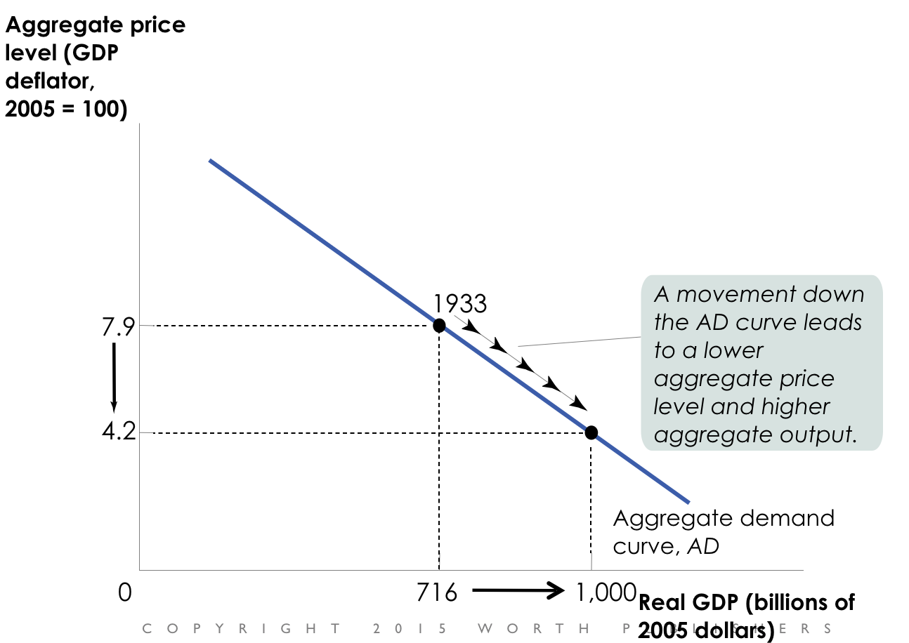

If we recall that GDP = C + I + G + X - IM, we can ask ourselves: why does a rise in the aggregate price level reduce C, I, and X − IM? (AKA, why does the AD curve slope downward?)

There are two reasons for this:

1. THE WEALTH EFFECT

A higher aggregate price level reduces the purchasing power of households’ wealth and reduces consumer spending.

1. THE INTEREST RATE EFFECT

A higher aggregate price level makes households hold more money and leads to a rise in interest rates (and a fall in investment spending and consumer spending).

We now drop the assumption that the overall price level is fixes. When the aggregate price level changes, the AEPlanned curve shifts. The AD curve is the application of the income-expenditure model at different prices.

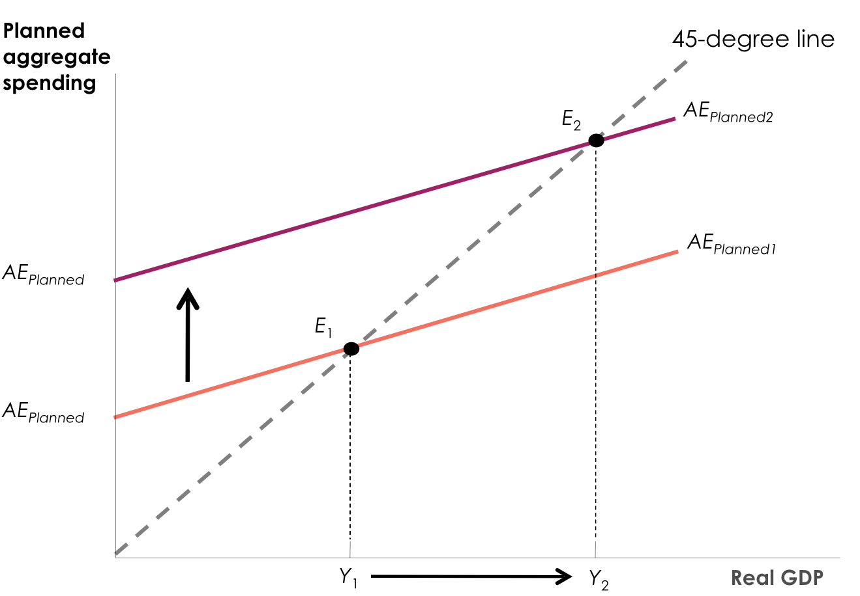

If the price level drops, planned spending rises at all output levels (from the wealth and interest-rate effects).

This leads to a multiplier process that moves the income–expenditure equilibrium from E1 to E2 and raises real GDP from Y1 to Y2.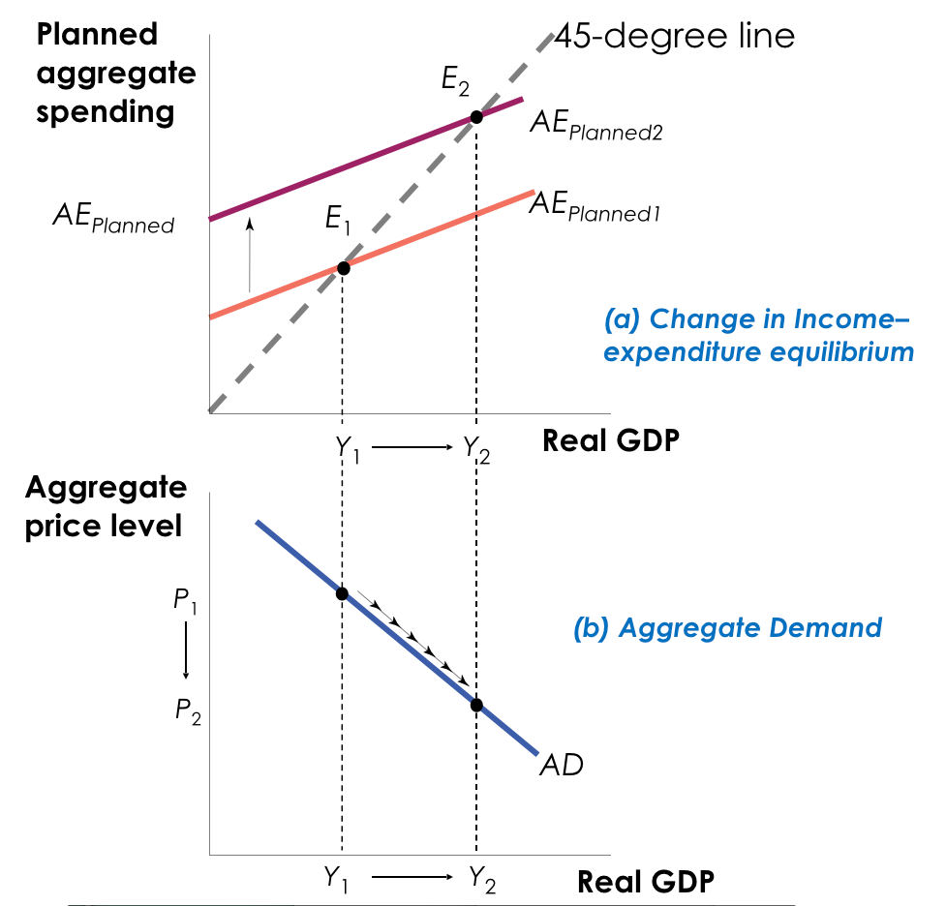

SHIFTS OF THE AGGREGATE DEMAND CURVEW

What happens when something changes spending patterns at every price level? The aggregate demand curve shifts because of changes in:

1. EXPECTATIONS

Consumers base their spending not only on current income but also on future income. Firms base their planned investment spending not only on current conditions but also on the sale they expect to make in the future.

1. WEALTH

Consumer spending depends in part on the value of household assets. When the real value of these assets rises, the purchasing power they embody also rises.

1. SIZE OF THE EXISTING STOCK OF PHYSICAL CAPITAL

Firms engage in planned investment spending to add to their stock of physical capital. Their incentive to spend depends in part on how much physical capital they already have. The more is the physical capital they already have, the less they will feel a need to add more, other things equal.

1. GOVERNMENT POLICIES (FISCAL/MONETARY POLICIES)

* FISCAL POLICIES

Fiscal policy is the use of either government spending — government purchases of final goods and services and government transfers — or tax policy to stabilise the economy.

* MONETARY POLICIES

The quantity of money in circulation is largely determined by the decisions of a central bank created by the government.

When the central bank increases the quantity of money in circulation, households and firms have more money, which they are willing to lend out, driving the interest rate down. This leads to higher investment spending and higher consumer spending.

THE SHORT-RUN AGGREGATE SUPPLY CURVE

The aggregate supply curve shows the relationship between the aggregate price level and the quantity of aggregate output in the economy:

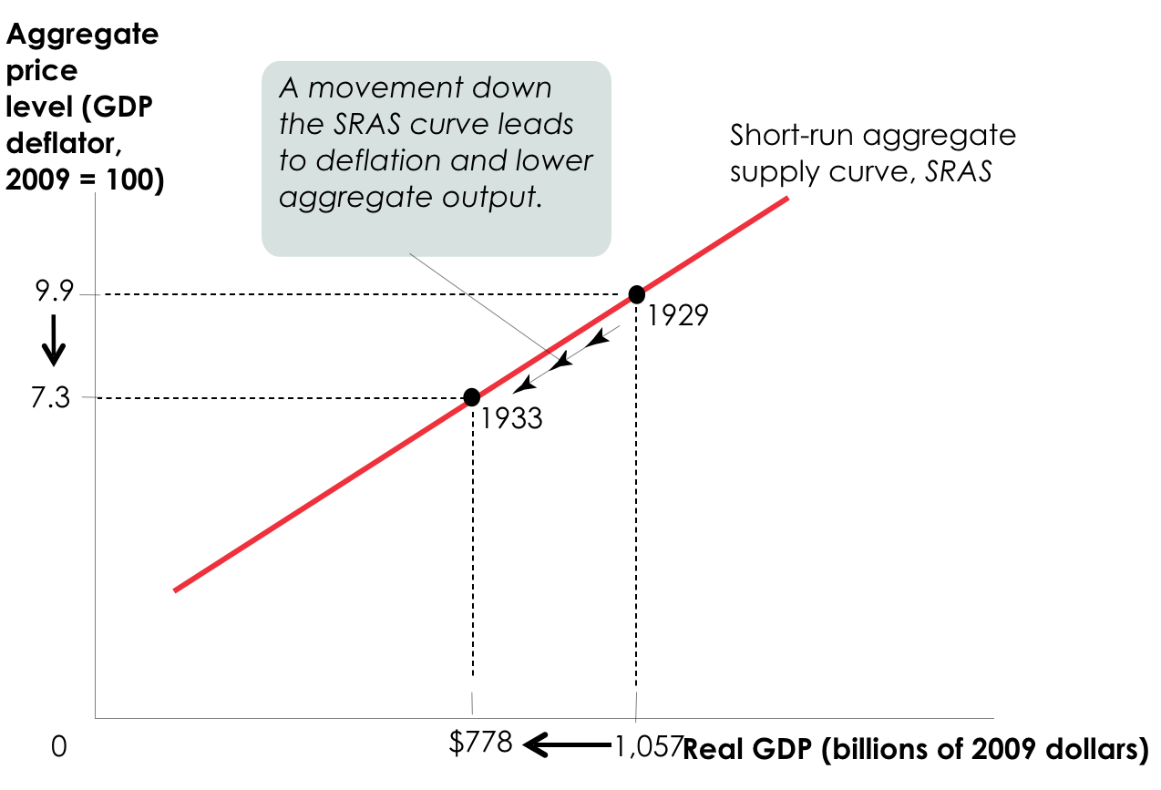

Why does the SRAS curve slope upward? Because nominal wages are stuck in the short run:

1. NOMINAL WAGE

The dollar amount of the wage paid.

1. STICKY WAGE

Nominal wages that are slow to fall even in the face of high unemployment and slow to rise even in the face of labor shortages.

How do sticky wages affect SRAS?

Nominal wages are often determined by contracts th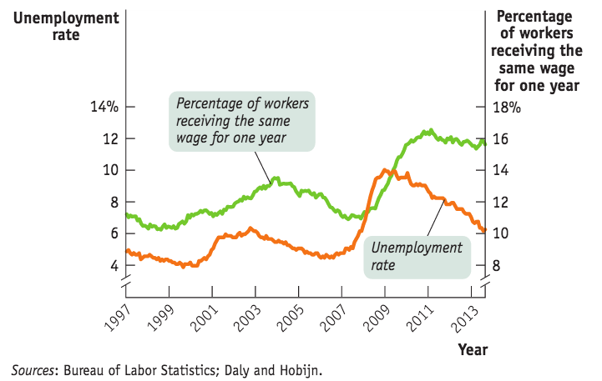at were signed some time ago. Even when there are no formal contracts, there are often informal agreements between management and workers. A higher aggregate price level leads to higher profits and increased aggregate output in the short run.

If the theory of sticky wages were true, we’d find evidence that wages fail to fall even during periods of high unemployment. We do.

Many firms are in very competitive industries, so they have no control over price. Some aren’t — and can raise price when demand is strong.

SHIFTS OF THE SHORT-RUN AGGREGATE SUPPLY CURVE

What happens when something changes production levels at every price level? The SRAS curve shifts because of changes in:

1. COMMODITY PRICES
2. NOMINAL WAGES
3. PRODUCTIVITY

Each of these factors changes producers’ profits and therefore shifts the SRAS. The SRAS curve shifts right because of a(n):

1. DECREASE IN COMMODITY PRICES
2. DECREASE IN NOMINAL WAGES
3. INCREASE IN PRODUCTIVITY

Each of these factors increases producers’ profits and shifts the SRAS right.

The SRAS curve will shift left because of a(n):

1. INCREASE IN COMMODITY PRICES
2. INCREASE IN NOMINAL WAGES
3. DECLINE IN PRODUCTIVITY

Each of these factors reduces producers’ profits and shifts the SRAS left.

LONG-RUN AGGREGATE SUPPLY CURVE

The long-run aggregate supply curve shows the relationship between the aggregate price level and the quantity of aggregate output supplied that would exist if all prices, including nominal wages, were fully flexible. The long run is the time it takes for all prices (including nominal wages) to adjust. Now, there is no change to profits simply because prices have changes.

Potential output is the level of real GDP the economy would produce if all prices, including nominal wages, were fully flexible.

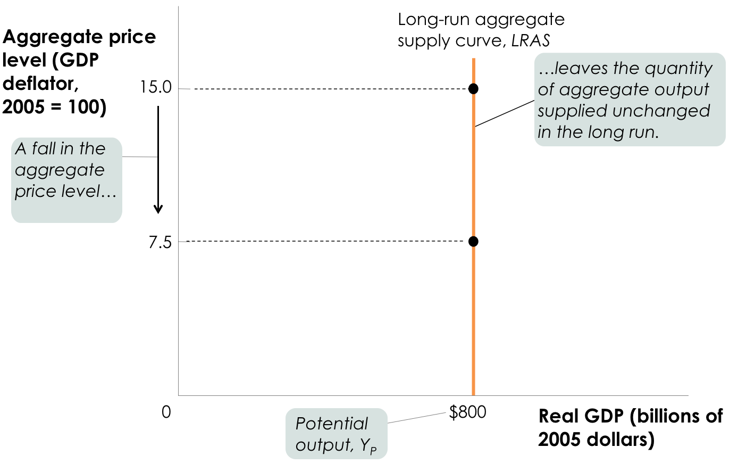

The level of real GDP is almost always either above or below potential output because of short-run fluctuations.

FROM THE SHORT RUN TO THE LONG RUN

If the economy finds itself at P1  on SRAS1, aggregate output supplied exceeds potential output (temporarily). Eventually, low 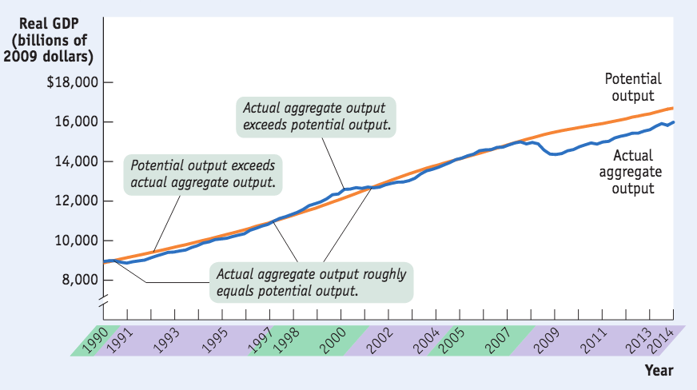unemployment will cause nominal wages to rise, and SRAS will shift left.

If the economy finds itself at P1  on SRAS1, aggregate output supplied falls short of potential output (temporarily). Eventually, high unemployment will cause nominal wages to fall, and SRAS will shift right.

THE AD-AS MODEL

The AD-AS model uses the aggregate supply curve and the aggregate demand curve together to analyse economic fluctuations.

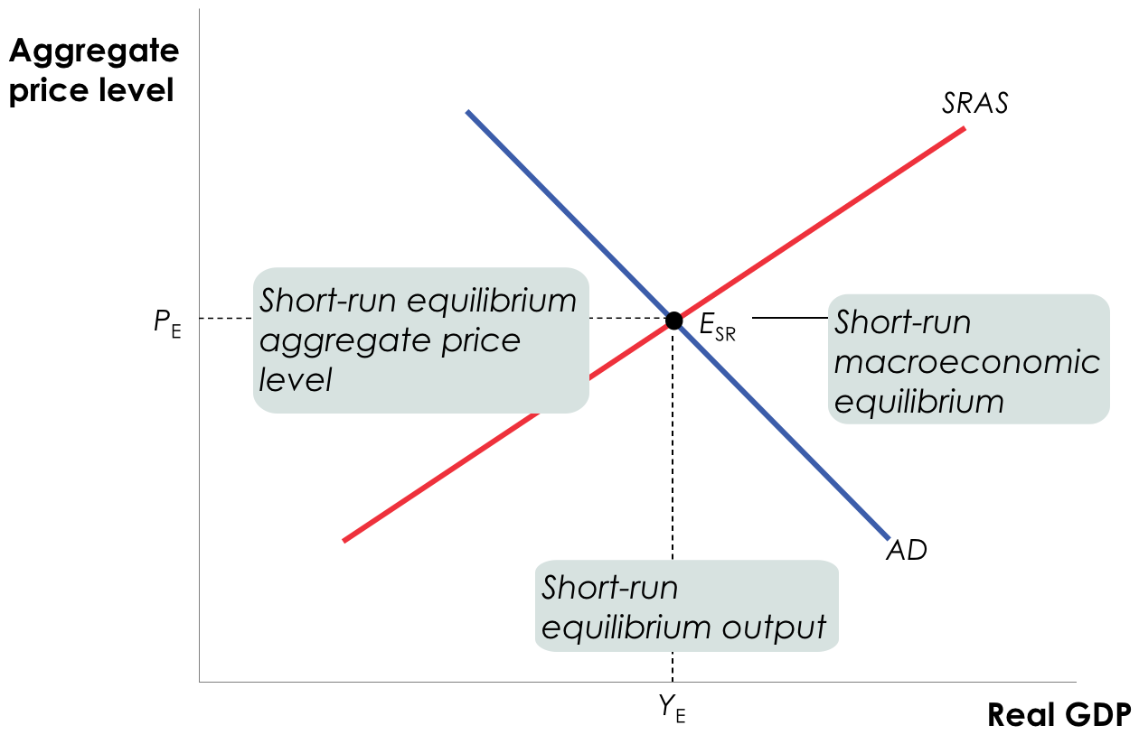

SHIFTS OF AGGREGATE DEMAND: SHORT-RUN EFFECTS

With a negative demand shock, total spending falls and total production falls at every price level, while with a positive demand shock, total spending rises. Lastly, with a positive supply shock, total production increases at every price level.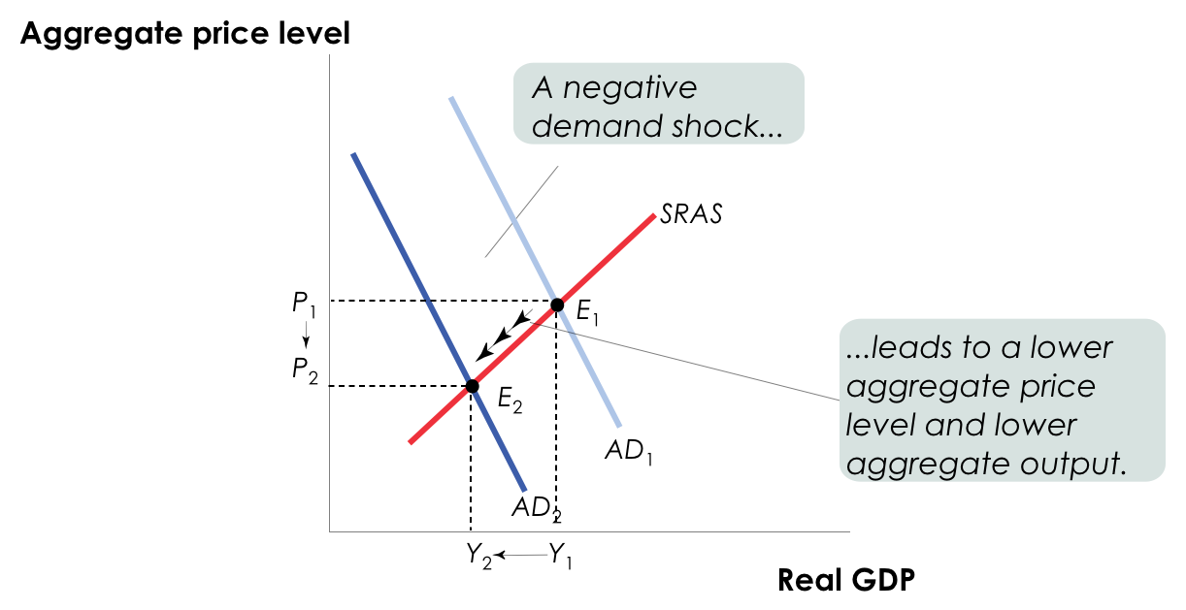

NEGATIVE SUPPLY SHOCKS AND STAGFLATION

Especially nasty for society is stagflation: the combination of inflation and falling aggregate output that comes with a negative supply shock. Negative supply shocks are rare but especially nasty!

LONG-RUN MACROECONOMIC EQUILIBRIUM

The economy is in long-run macroeconomic equilibrium when the point of short-run macroeconomic equilibrium is on the long-run aggregate supply curve. This economy below, for example, is in short and long-run macroeconomic equilibrium: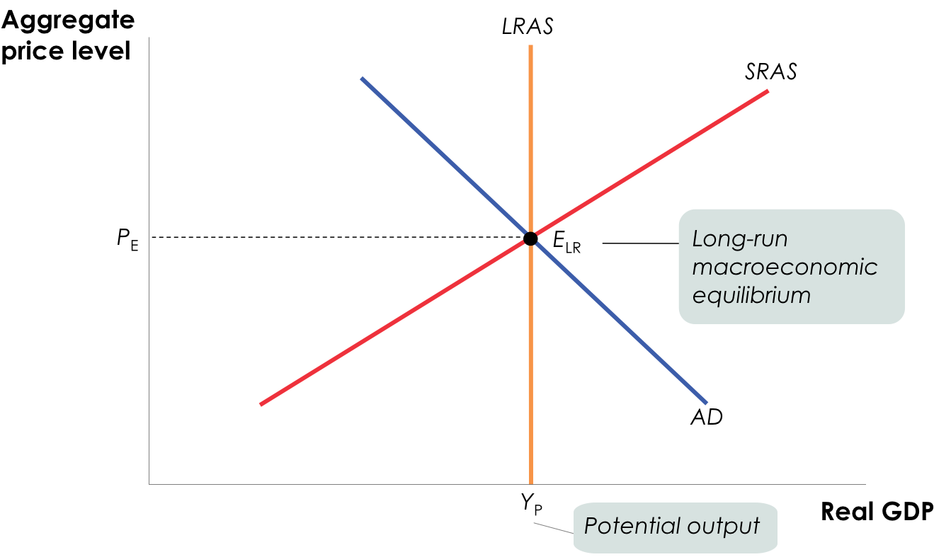

If a demand or supply shock hits the economy, AD or SRAS shifts and moves the economy to a new short-run equilibrium.

SHORT-RUN VERSUS LONG-RUN EFFECTS OF A NEGATIVE DEMAND SHOCK

An initial negative demand shock reduces the aggregate price level and aggregate output and leads to higher unemployment in the short run, until a fall in nominal wages in the long run increases short-run aggregate supply and moves the economy back to potential output.

SHORT-RUN EFFECTS OF A POSITIVE DEMAND SHOCK

An initial positive demand shock increases the aggregate price level and aggregate output and leads to lower unemployment in the short run, until a rise in nominal wages in the long run reduces short-run aggregate supply and moves the economy back to potential output.

GAPS

Within macroeconomics, there are various types of gaps we should keep an eye out for:

1. RECESSIONARY GAP

When aggregate output is below potential output.

1. INFLATIONARY GAP

When aggregate output is above potential output.

1. OUTPUT GAP

The % difference between actual aggregate output and potential output; it can be calculated as:

Output gap = (Actual aggregate output - Potential output) / (Potential output) x 100

The money may correct itself in the long run if wages and prices fully adjust.

MACROECONOMIC POLICY

It’s true that the economy is self-correcting in the long run. Most economists think it takes a decade or longer. Within this field, a stabilisation policy indicates the use of government policy to reduce the severity of recessions and rein in excessively strong expansions. John Maynard Keynes (1883–1946) actually created the modern field of macroeconomics.

RESPONDING TO SUPPLY SHOCKS

Negative supply shocks pose a policy dilemma: to stabilise aggregate output, we are required to increase aggregate demand, which in turn leads to inflation.

To stabilise prices, on the other hand, we must reduce aggregate demand, which will deepen the output slump.

Fiscal Policy

Fiscal policy is the use of taxes, government transfers, or government purchases of goods and services to shift the aggregate demand curve. Governments typically use fiscal policy to promote strong and sustainable growth and reduce poverty through various programs, such as social insurance programs (intended to protect families against economic hardship) and government transfers (payments by the government to households for which no good or service is provided in return).

Taxation and government spending have a strong effect on total aggregate spending in the economy. Let’s take GDP once more:

GDP = C + I + G + X - IM

The government directly controls G (government spending) and indirectly affects C (consumption) and I. But how?

Household incomes are affected by taxes and transfers, and business investment is affected by taxes and regulations, and thus the government has the ability to shift the AD curve.

EXPANSIONARY AND CONTRACTIONARY FISCAL POLICY

There are two main types of fiscal policy:

1. EXPANSIONARY

Expansionary fiscal policy can be viewed as extra fuel for the economy. This is fiscal policy that increases aggregate demand through:

* An increase in government purchases of goods and services
* A cut in taxes
* An increase in government transfers

Expansionary fiscal policy can also close a recessionary gap. Instead of waiting for the long-run correction mechanism, policy makers could choose to stimulate AD and move the economy back toward long-run equilibrium.

1. CONTRACTIONARY

Contractionary fiscal policies are the “brakes” for the economy. This is fiscal policy that decreases aggregate demand through:

* A reduction in government purchases of goods and services
* An increase in taxes
* A reduction in government transfers

Contractionary fiscal policy can close an inflationary gap. Instead of waiting for the long-run correction mechanism, policy makers could choose to contract AD and move the economy back toward long-run equilibrium.

THE UTILITY OF EXPANSIONARY FISCAL POLICY

Can expansionary fiscal policy actually work? There are critics who pose various arguments:

1. “Government spending always crowds out private spending.”

This statement is wrong because it assumes a zero-sum game in which the aggregate income earned in the economy is always a fixed sum — which isn’t true. It also assumes that resources in the economy are always fully employed — and the only way to increase government spending is at firms’ expense.

When the economy is suffering from a recessionary gap, there are unemployed resources in the economy and output, and therefore income, is below its potential level.

Government spending crowds out private spending only when the economy is operating at full employment.

1. “Government borrowing always crowds out private investment spending.”

This is true only part of the time: It depends upon whether the economy is depressed. If it is, a fiscal expansion will lead to higher incomes, which lead to increased savings.

The Recovery Act of 2009 was a case in point: despite high levels of government borrowing, U.S. interest rates stayed near historic lows.

Government borrowing crowds out private investment spending only when the economy is operating at full employment.

1. “Government budget deficits reduce private spending.”

This is known as “Ricardian equivalence” (after the nineteenth-century economist David Ricardo). It assumes that consumers, seeing the higher debt levels, will cut their spending today to save for inevitable increases in future tax rates necessary to pay down the debt.

Does this give too much credit to consumers’ foresight and budgeting discipline? Probably.

In sum, the extent to which we should expect expansionary fiscal policy to work depends upon the circumstances. When the economy has a recessionary gap, economics tells us that expansionary fiscal policy helps the economy.

However, when the economy is already at full employment, expansionary fiscal policy is the wrong policy and will lead to crowding out and higher inflation.

A CAUTIONARY NOTE: LAGS IN FISCAL POLICY

In the case of fiscal policy, there is an important reason for caution: There are significant lags in its use.

It takes time to:

1. Realise the recessionary or inflationary gap by collecting and analysing economic data
2. Develop a plan
3. Implement the action plan (spending the money)

If we wanted to talk about recession, we should probably speak of the American Recovery and Reinvestment Act of 2009. One effect of the recession was a sharp drop in revenues at the state and local levels, which in turn forced these lower levels of government to cut spending. Federal aid was sent to mitigate these cuts.

FISCAL POLICY AND THE MULTIPLIER

Let’s recall that the multiplier is:

1/(1 - MPC)

With regards to the multiplier effects of changes in government transfers and taxes, will a $50 billion tax cut (or increase in transfers) have the same effect as a $50 billion increase in government purchases?

No. Example: if the MPC = 0.5, a change in tax or transfers is smaller than an equivalent change in government purchases from the outset.

The size of the shift of the aggregate demand curve depends on the type of fiscal policy. Changes in government purchases have a more powerful effect on the economy than equal-sized changes in taxes or transfers.

It’s actually more complicated, because (unlike most real tax policy) we use simple lump-sum taxes: taxes that don’t depend on the taxpayer’s income. If it’s not a lump-sum tax, the tax revenue will depend on the level of real GDP (and reduce the size of the multiplier).

TYPES OF FISCAL POLICY

Automatic stabilisers are government spending and taxation rules that cause fiscal policy to be automatically expansionary when the economy contracts and automatically contractionary when the economy expands (unemployment insurance).

In contrast, discretionary fiscal policy arises from deliberate actions by policy makers rather than rules (the Obama stimulus).

THE BUDGET BALANCE

How do surpluses and deficits fit into the analysis of fiscal policy? Are deficits ever a good thing and surpluses a bad thing?

A budget surplus is a positive budget balance, and a budget deficit is a negative budget balance. Other things equal, discretionary expansionary fiscal policies reduce the budget balance for that year. Other things equal, discretionary contractionary fiscal policies increase the budget balance for that year.

SGovernment = T - G - TR

(Government saving = tax revenues - government purchases - transfers)

DEFICITS VS DEBT

A deficit is the difference between the amount of money a government spends and the amount it receives in taxes over a given period (flow variable). A debt, on the other hand, is the sum of money a government owes at a particular time (stock variable).

Deficits and debts are linked because government debt grows when governments run deficits. But they aren’t the same thing, and they can tell different stories. A widely used measure of fiscal health is actually the debt-GDP ratio.

THE BUDGET BALANCE MEASURES FISCAL POLICY

Economists often consider the changes in the budget balance to measure fiscal policy. However, this “quick-and-dirty” way to assess whether current fiscal policy is expansionary or contractionary is sometimes misleading:

1. Two different changes in fiscal policy that have equal-sized effects on the budget balance may have quite unequal effects on the economy
2. Often, changes in the budget balance are themselves the result, not the cause, of fluctuations in the economy

THE BUDGET BALANCE AND THE BUSINESS CYCLE

Some of the fluctuations in the budget balance are due to the effects of the business cycle. The budget deficit as a percentage of GDP moves closely with the unemployment rate.

Is this relationship between the business cycle and the budget balance evidence that policy makers engage in discretionary fiscal policy during expansions?

Not necessarily. To a large extent, the relationship between budget balance and business cycle reflects automatic stabilisers at work (i.e. unemployment benefit payments).

THE BUSINESS CYCLE AND THE CLINICALLY ADJUSTED BUDGET BALANCE

To separate the effects of the business cycle from the effects of discretionary fiscal policy, governments estimate the cyclically adjusted budget balance: an estimate of the budget balance if the economy were at potential output.

PHILOSOPHIES ON BALANCING THE BUDGET

There are various philosophies about requiring a balanced budget:

1. Require an annually balanced budget and lose the ability to help during a recession
2. Balance the budget over the business cycle on average and trust the politicians to keep the long-run budget healthy?

EUROPE’S SEARCH FOR A FISCAL RULE

In 1999, some European nations adopted the euro. Each government was required to keep its budget deficit below 3% of the country’s GDP or face penalties. This pact limited a country’s ability to use fiscal policy.

Then, after the 2008 financial crisis, Greece, Ireland, Portugal, Spain, and Italy lost the confidence of their investors, who worried they couldn’t pay their debt.

Was it too much debt? No, only Greece had a deficit above 3% of GDP; Ireland and Spain ran surpluses.

BUDGET POLICY IN THE U.S.

The United States has its own version of the original, flawed European stability pact. The constitutions of 49 of the 50 states require a balanced budget every year.

When recession struck in 2008, most states were forced to slash spending and raise taxes in the face of a recession, exactly the wrong thing from a macroeconomic point of view.

Europe has since changed to a rule that requires a mostly balanced structural budget.

LONG-RUN IMPLICATIONS OF FISCAL POLICY

Persistent budget deficits have long-run consequences because they lead to an increase in public debt. In 2008, the government of Greece could borrow at interest rates barely higher than those of Germany, widely considered a very safe borrower. Things changed, however, in 2009.

THE SOCIAL COST OF DEBT

Greece imposed severe spending cuts to qualify for loans. Greeks angered by their government’s harsh austerity measures took to the streets in protest- and installed a new party to power.

PROBLEMS POSED BY RISING GOVERNMENT DEBT

Public debt may crowd out investment spending, which reduces long-run economic growth. In extreme cases, rising debt may lead to government default, resulting in economic and financial turmoil.

Can’t a government that has trouble borrowing just print money to pay its bills? Yes, it can, but this leads to another problem: inflation.

Monetary Policy

The opportunity cost of holding money is the interest forgone on an alternative asset. The opportunity cost of holding money is the nominal interest because it is the sum of the real interest rate on an alternative asset plus the expected inflation rate, which is the rate at which money loses buying power.

We all carry some cash around for the convenience, and when we do, we give up interest income we’d collect if that spending power were in an interest-bearing asset like a bond.

Individuals and firms trade off the benefit of holding cash versus the benefit of holding interest-bearing non-monetary assets. There are two main types of interest rates:

1. SHORT-TERM INTEREST RATES

The interest rates on financial assets that mature within six months or less.

1. LONG-TERM INTEREST RATES

The interest rates on financial assets that mature a number of years in the future.

The higher the interest rate, the higher the opportunity cost of holding money. The lower the interest rate, the lower the opportunity cost of holding money. Although there are many different interest rates and they don’t move exactly together, as a rule most short-term rates tend to move in the same direction.

THE MONEY DEMAND CURVE

The money demand curve shows the relationship between the quantity of money demanded and the interest rate. At lower interest rates, the cost of holding money is smaller, so a higher quantity is demanded. At higher interest rates, the cost of holding money is greater, so less quantity is demanded.

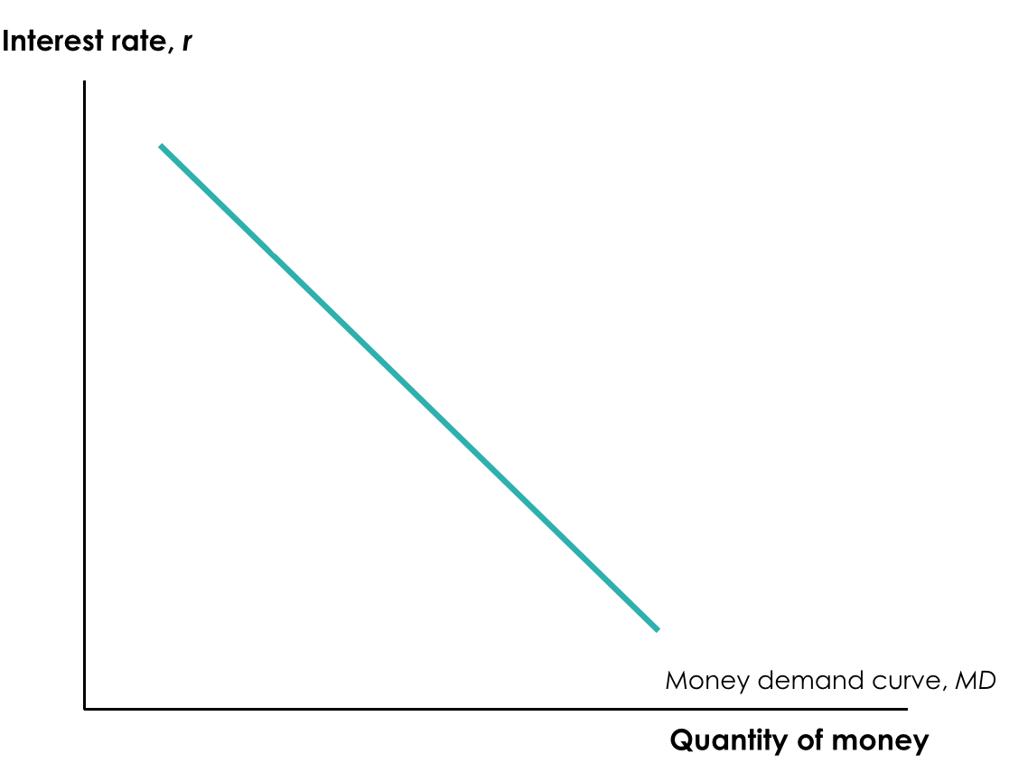

SHIFTS OF THE REAL MONEY DEMAND CURVE

The following factors shift the money demand curve:

1. CHANGES IN AGGREGATE PRICE LEVEL

Higher prices mean we need more money for transactions (and vice versa).

1. CHANGES IN REAL GDP

More goods and services produced and sold means we need more money (and vice versa).

1. CHANGES IN TECHNOLOGY

The ease of credit card payments reduces the need for cash.

1. CHANGES IN INSTITUTIONS

After 1980 banks were allowed to offer interest on checking accounts. This decreased the cost of holding money, and money demand increased.

In Japan, for example, many small businesses haven’t invested in credit card technology. The short-term interest rates have been below 1% since the 1990’s, and crime is low. So…why not hold cash?

SHIFTS IN THE DEMAND FOR MONEY

A fall in money demand shifts the money demand curve to the left, while a rise in money demand shifts the money demand curve to the right.

MONEY AND INTEREST RATES

So how does the Fed control interest rates?

We need to understand how interest rates are set in the market. The liquidity preference model of the interest rate asserts that the interest rate is determined by the supply and demand for money. The money supply curve shows how the nominal quantity of money supplied varies with the interest rate.

EQUILIBRIUM IN THE MONEY MARKET

At rH, interest rates are high. MS > MD, and a surplus of money means there is a shortage of other assets like bonds. Investors selling bonds will realise they can reduce interest rates and still find buyers.

At rL , on the other hand, interest rates are low. MD > MS, and a shortage of money means there is a surplus of other assets like bonds. Investors selling bonds will try to make them more attractive to buyers by raising rates.

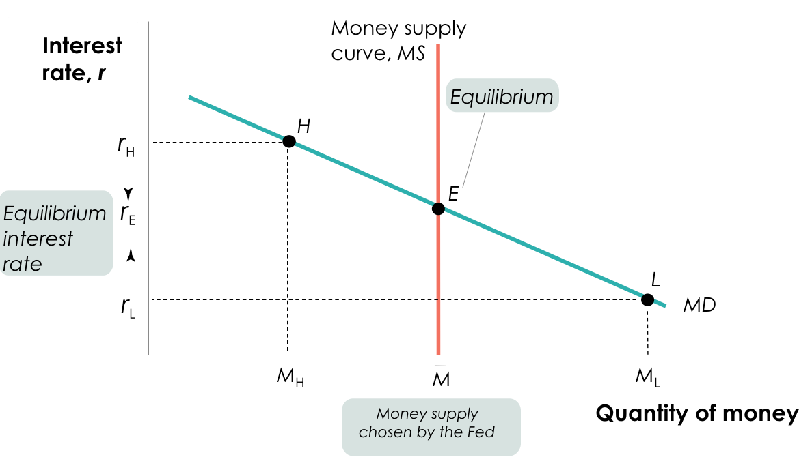

MONETARY POLICY AND THE INTEREST RATE

By adjusting the money supply up or down, the Fed can set the interest rate. The Fed sets a target federal funds rate and undertakes the appropriate open-market operations.

There are several types of interest rates:

1. FEDERAL FUNDS RATE

The interest rate at which funds are borrowed and lent in the federal funds market.

1. FEDERAL FUNDS MARKET

A financial market that allows banks that fall short of the reserve requirement to borrow reserves (usually overnight) from banks that are holding excess reserves).

1. TARGET FEDERAL FUNDS RATE

The Federal Reserve’s desired federal funds rate.

Like the banks it oversees, the Fed has assets ad liabilities.

The Fed’s assetsconsist of holdings of debt issues by the U.S. government, mainly short term U.S. government bonds with a maturity of less than one year, known as U.S. Treasury bills. The Fed’s liabilities consist of currency in circulation and bank reserves.

With regard to open market operations, the Fed buys or sells U.S. Treasury bills, normally through a transaction with commercial banks. The Fed uses open-market operations to push the interest rate down to the target rate; an open-market purchase of Treasury bills drives the interest rate down.

The Fed also uses open-market operations to pull the interest rate up to the target rate, as an open-market sale of Treasury bills drives the interest rate up.

THE TARGET VERSUS THE MARKET

A common mistake is to imagine that changes in the way the Federal Reserve operates alter the way the money market works. In fact, the money market works the same way as always: the interest rate is determined by the supply and demand for money.

The only difference is that now the Fed adjusts the supply of money to achieve its target interest rate.

LONG-TERM INTEREST RATES

Long-term interest rates don’t necessarily move with short-term interest rates. If investors expect short-term interest rates to rise, they may buy short-term bonds.

In practice, long-term interest rates reflect the market’s average expectation for short-term rates.

MONETARY POLICY AND AGGREGATE DEMAND

There are two types of monetary policy:

1. EXPANSIONARY MONETARY POLICY

Monetary policy that increases aggregate demand (also called “easy money policy”).

1. CONTRACTIONARY MONETARY POLICY

Monetary policy that reduces aggregate demand (also called “tight money policy”).

The expansionary monetary policy cycle works in intricate ways:

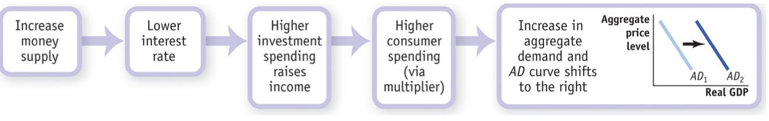

The contractionary monetary policy, on the other hand, has a different mechanism:

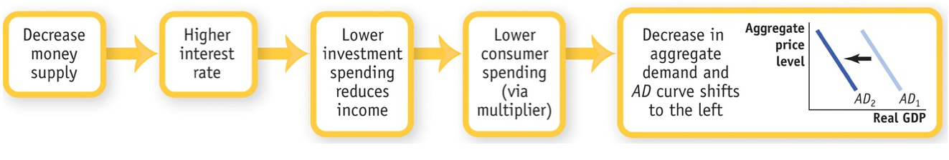

MONETARY POLICY IN PRACTICE

How does the Fed decide whether to use expansionary or contractionary monetary policy? And how does it decide how much is enough?

Policy makers try to fight recessions, as well as to ensure price stability: low (though usually not zero) inflation. Actual monetary policy reflects a combination of these goals.

TRACKING MONETARY POLICY

The federal funds rate usually rises when the output gap is positive and falls when the output gap is negative, while the federal funds rate tends to be high when inflation is high and low when inflation is low.

THE TAYLOR RULE FOR MONETARY POLICY

In 1993, Stanford economist John Taylor proposed a simple rule for monetary policy: the Taylor rule for monetary policy. This rule instructs individuals to set the federal funds rate according to the level of the inflation rate and either the output gap or the unemployment rate.

To address both inflation and recessions, the Fed can follow the following rule:

2.07 + 1.28 x inflation rate - 1.95 x unemployment gap

The actual federal funds rate tracked the predicted rate quite closely through the end of 2008. After that the Taylor rule called for negative interest rates, which aren’t possible.

INFLATION TARGETING

Instead of using a Taylor rule, many central banks use inflation targeting, which is practically the central bank setting an explicit target for the inflation rate and using monetary policy to hit that target.

DOES IT MATTER?

There is one major difference between the two methods: inflation targeting is forward-looking (based on a forecast of future inflation), while the Taylor rule is backward-looking (adjusts monetary policy in response to past inflation).

THE ZERO LOWER BOUND PROBLEM

The fact that interest rates can’t go below zero (“zero lower bound”) limits the power of monetary policy. In November 2010, interest rates were at or near zero, but the economy was still far below potential output. So the Fed got creative and tried “quantitative easing” (buying longer-term government bonds). The Fed hoped this would drive down long-term interest rates and have an expansionary effect on the economy.

At the end of 2010 the Fed began an attempt to circumvent the zero lower bound problem through the Quantitative Easing (QE). Instead of purchasing only short-term government debt, it began buying longer-term government debt, i.e. five-year or six-year bonds, rather than three month Treasury bills.

At the end of 2010 short term rates were near zero, but rates on longer-term bonds were between 2% and 3%. The Fed hoped that direct purchases of these longer-term bonds would drive down interest rates on long-term debt, exerting an expansionary effect on the economy.

QE IN EUROPE

On 22 January 2015 Mario Draghi, President of the European Central Bank, announced an 'expanded asset purchase programme': where €60 billion per month of euro-area bonds from central governments, agencies and European institutions would be bought.

Beginning in March 2015, the stimulus was planned to last until September 2016 at the earliest with a total QE of at least €1.1 trillion. Mario Draghi announced the programme would continue: 'until we see a continued adjustment in the path of inflation', referring to the ECB's need to combat the growing threat of deflation across the eurozone in early 2015.

MONEY, OUTPUT, AND PRICES IN THE LONG RUN

Through its expansionary and contractionary effects, monetary policy is generally the policy tool of choice to help stabilise the economy. However, not all actions by central banks are productive. Sometimes central banks print money not to fight a recessionary gap but to help the government pay its bills, an action the typically destabilise the economy.

What about the economy’s ability to self-correct toward long-run equilibrium through flexible wages and SRAS shifts?

In short, we believe that in the long run, changes in the quantity of money affect the price level but not the output or interest rate: monetary neutrality.

In sum, an increase in the money supply reduces the interest rate and increases aggregate demand, but the eventual rise in nominal wages leads to a fall in short-run aggregate supply, and aggregate output falls back to potential output.

MONETARY NEUTRALITY

Monetary neutrality refers to changes in the money supply have no real effect on the economy. In the short run, monetary policy has powerful real effects on the economy, often making the difference between recession and expansion.

LONG-RUN CHANGES IN THE MONEY SUPPLY AND INTEREST RATE

In the long run, changes in the money supply don’t affect the interest rate. An increase in the money supply lowers the interest rate in the short run, but in the long run higher

prices lead to greater money demand, raising the interest rate to its original level.

So, do increases in the money supply really lead to increases in the price level? It’s not exact, but yes.